**User Manual**

**Detailed User Manual**

1. **Login and Registering**

When a user enters the first page, he or she can choose to login, register, apply unity and confirm unity. The reason why we put four functions on the first page is that the elderly may have some problem with logging into their accounts and routing into the final page they want.

1. **User Login**

Users input their identification number and password into the empty form. Due to the lack of ID verification API, we set a simple rule using regular matching. After inputting their information and logging into the system successfully, the browser gets a new token stored in the localstorage which will expire in 15 days.

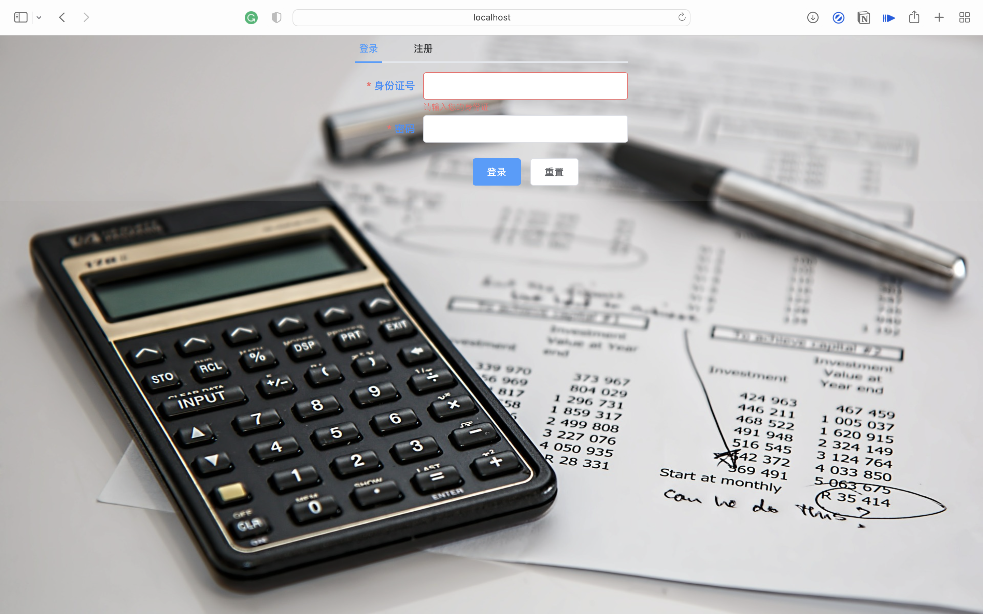

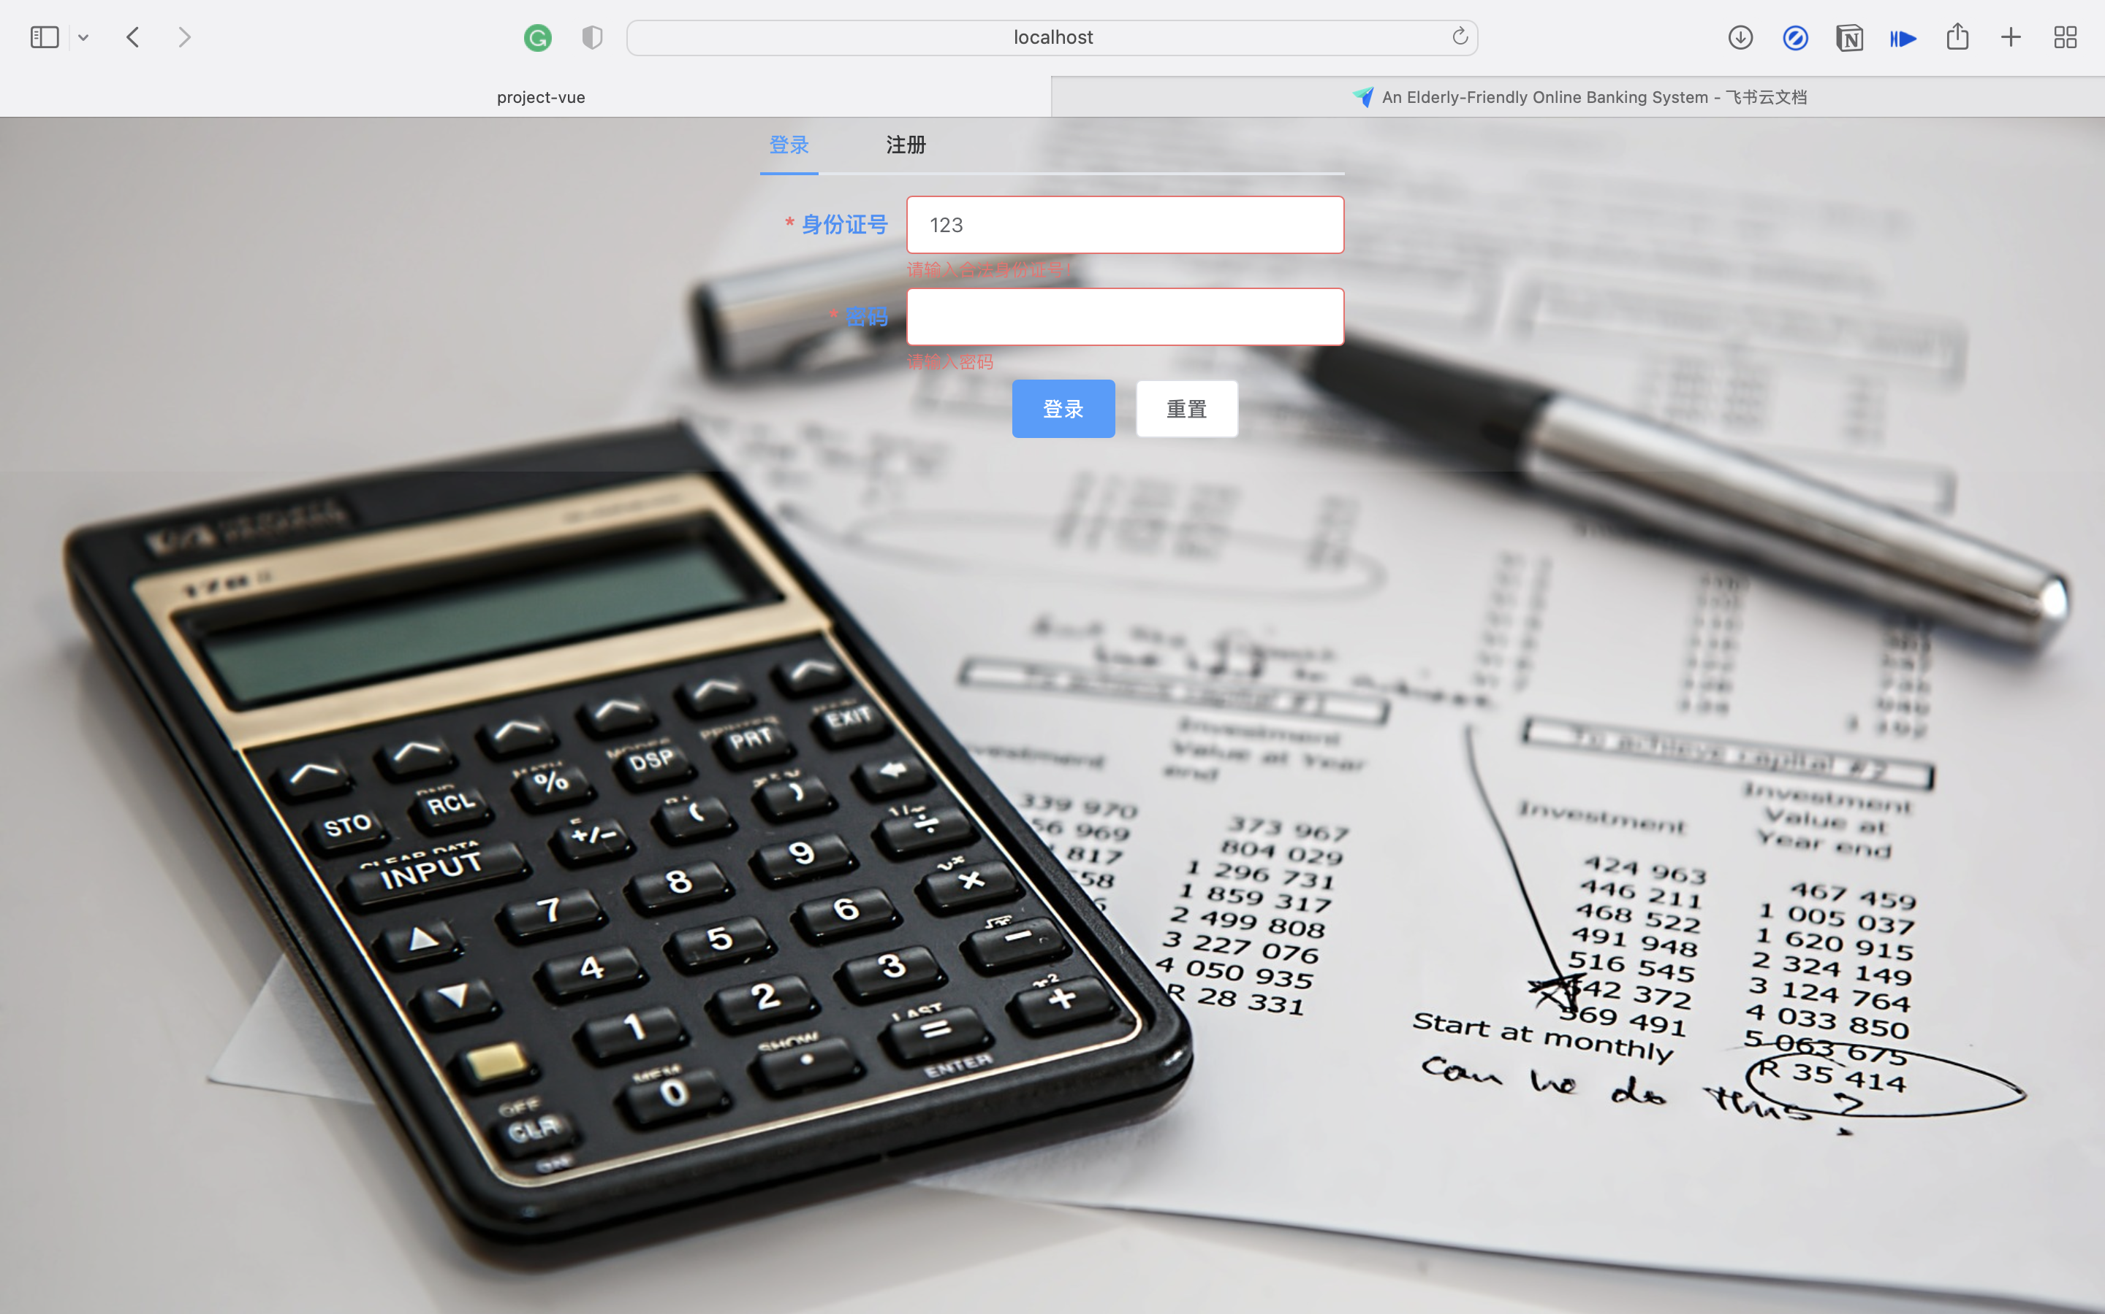

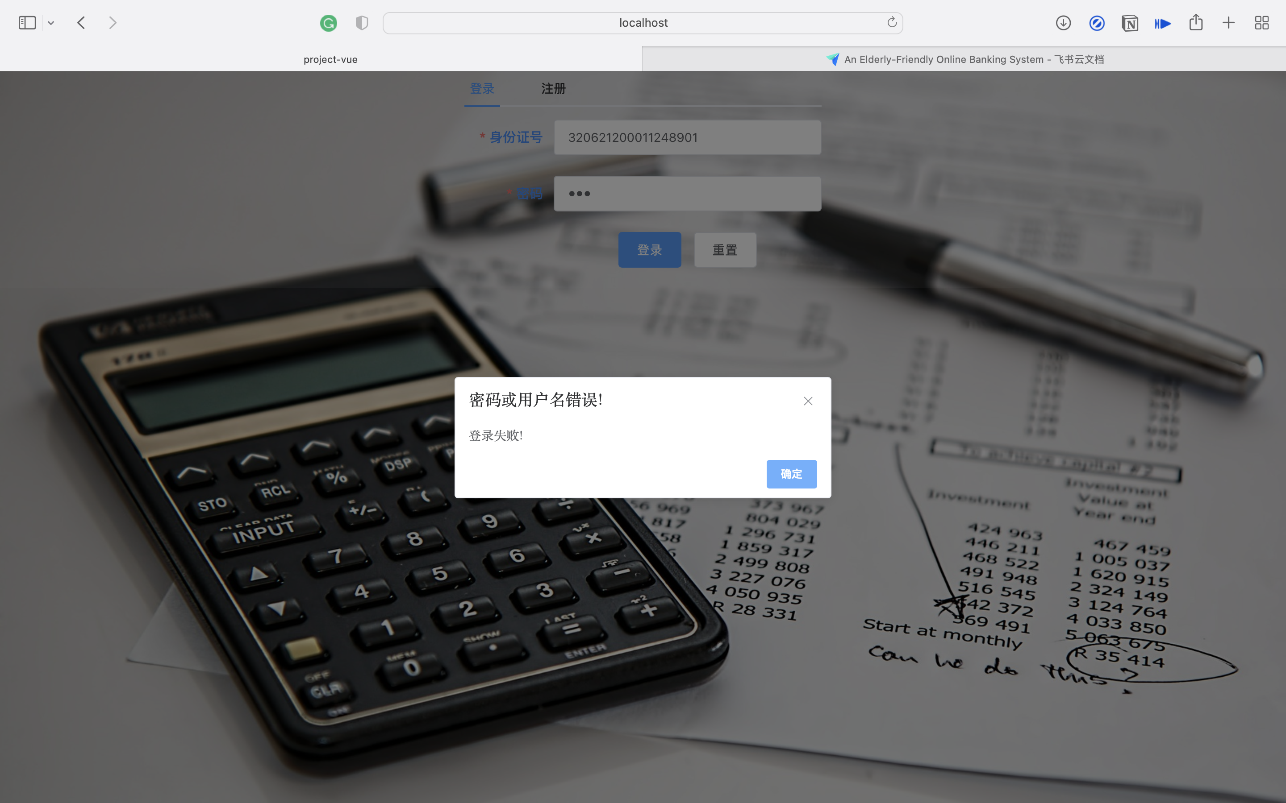

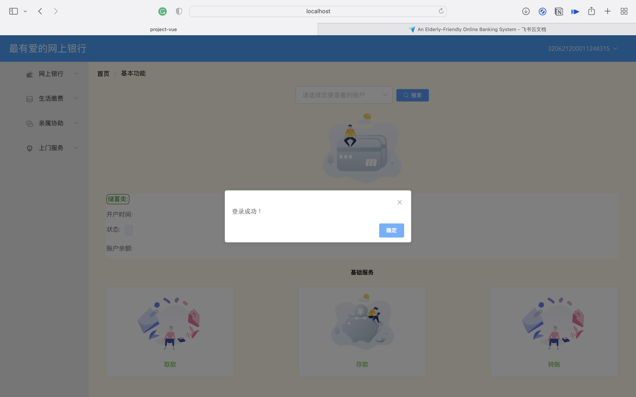

1. **New User Registering**

Users input their identification number and password into the empty form. Due to the lack of ID verification API, we set a simple rule using regular matching. After inputting their information, the system will check if the identification number has been registered. If the identification number has not been registered, the system will insert the register information into the database and the browser gets a new token stored in the localstorage which will expire in 15 days.

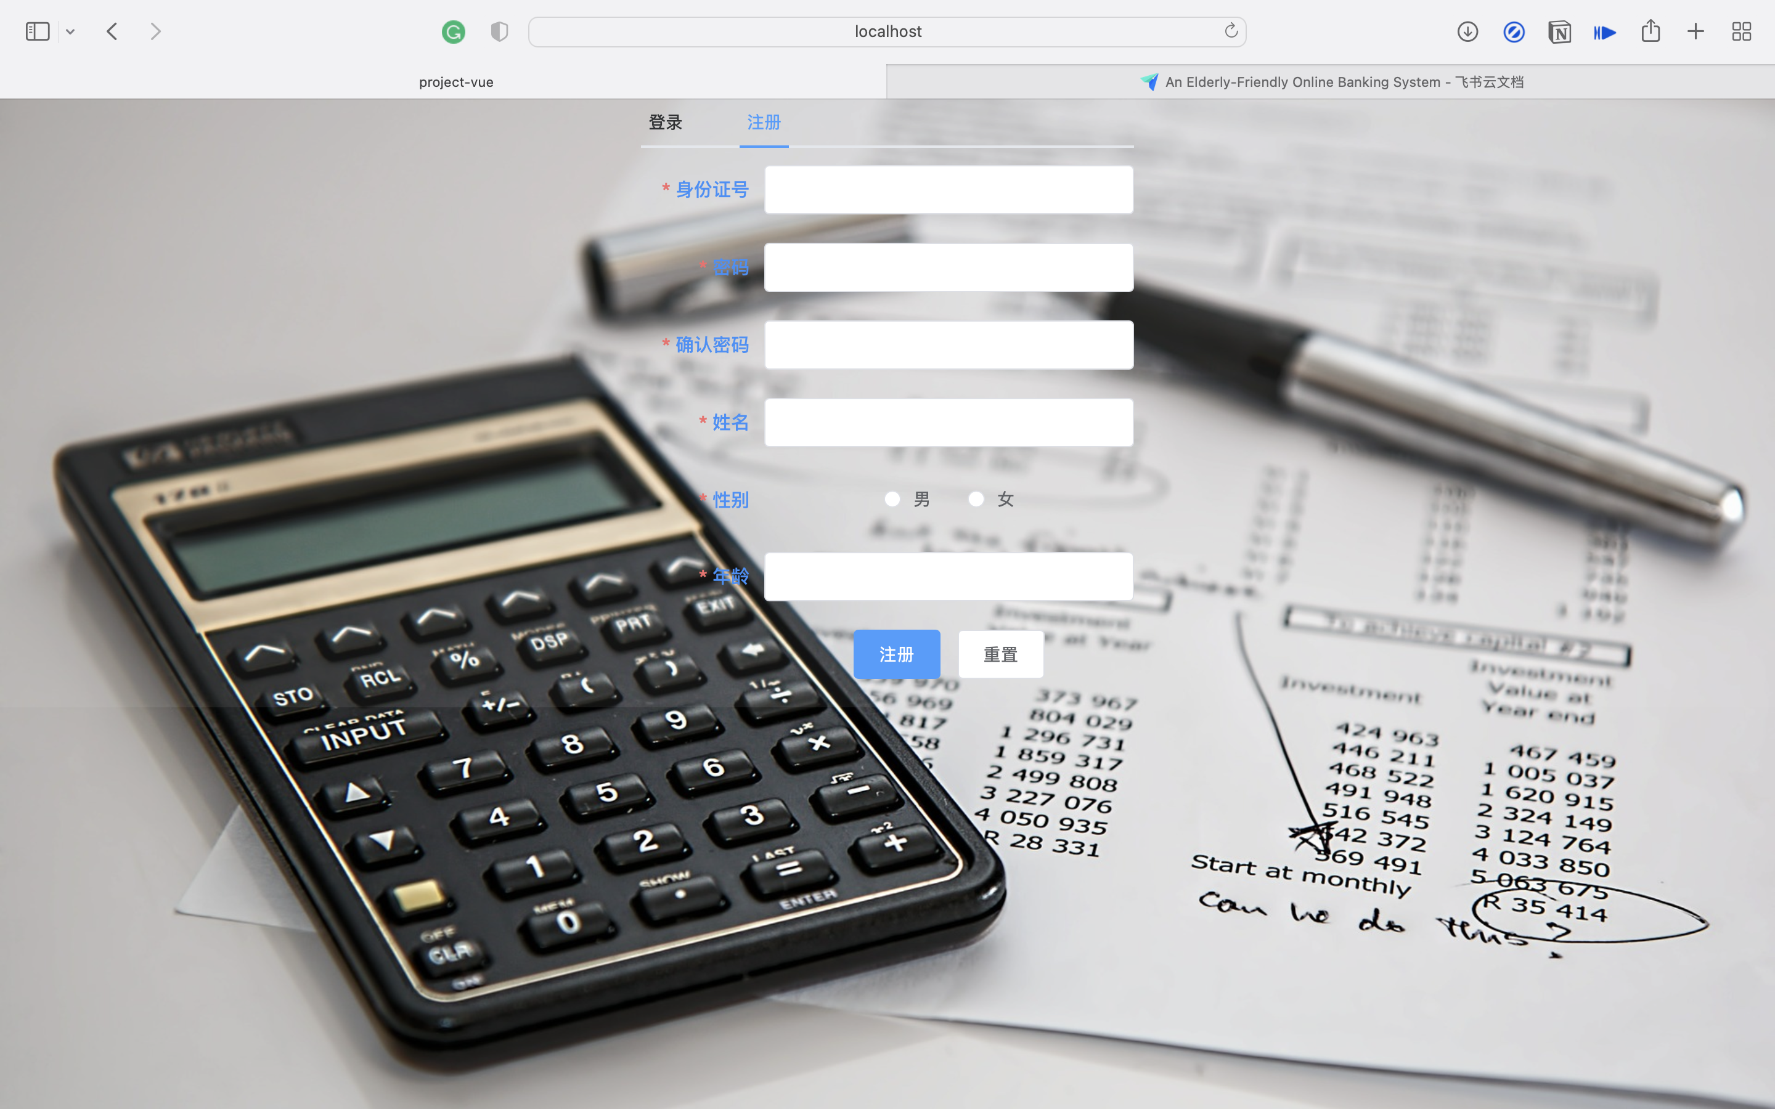

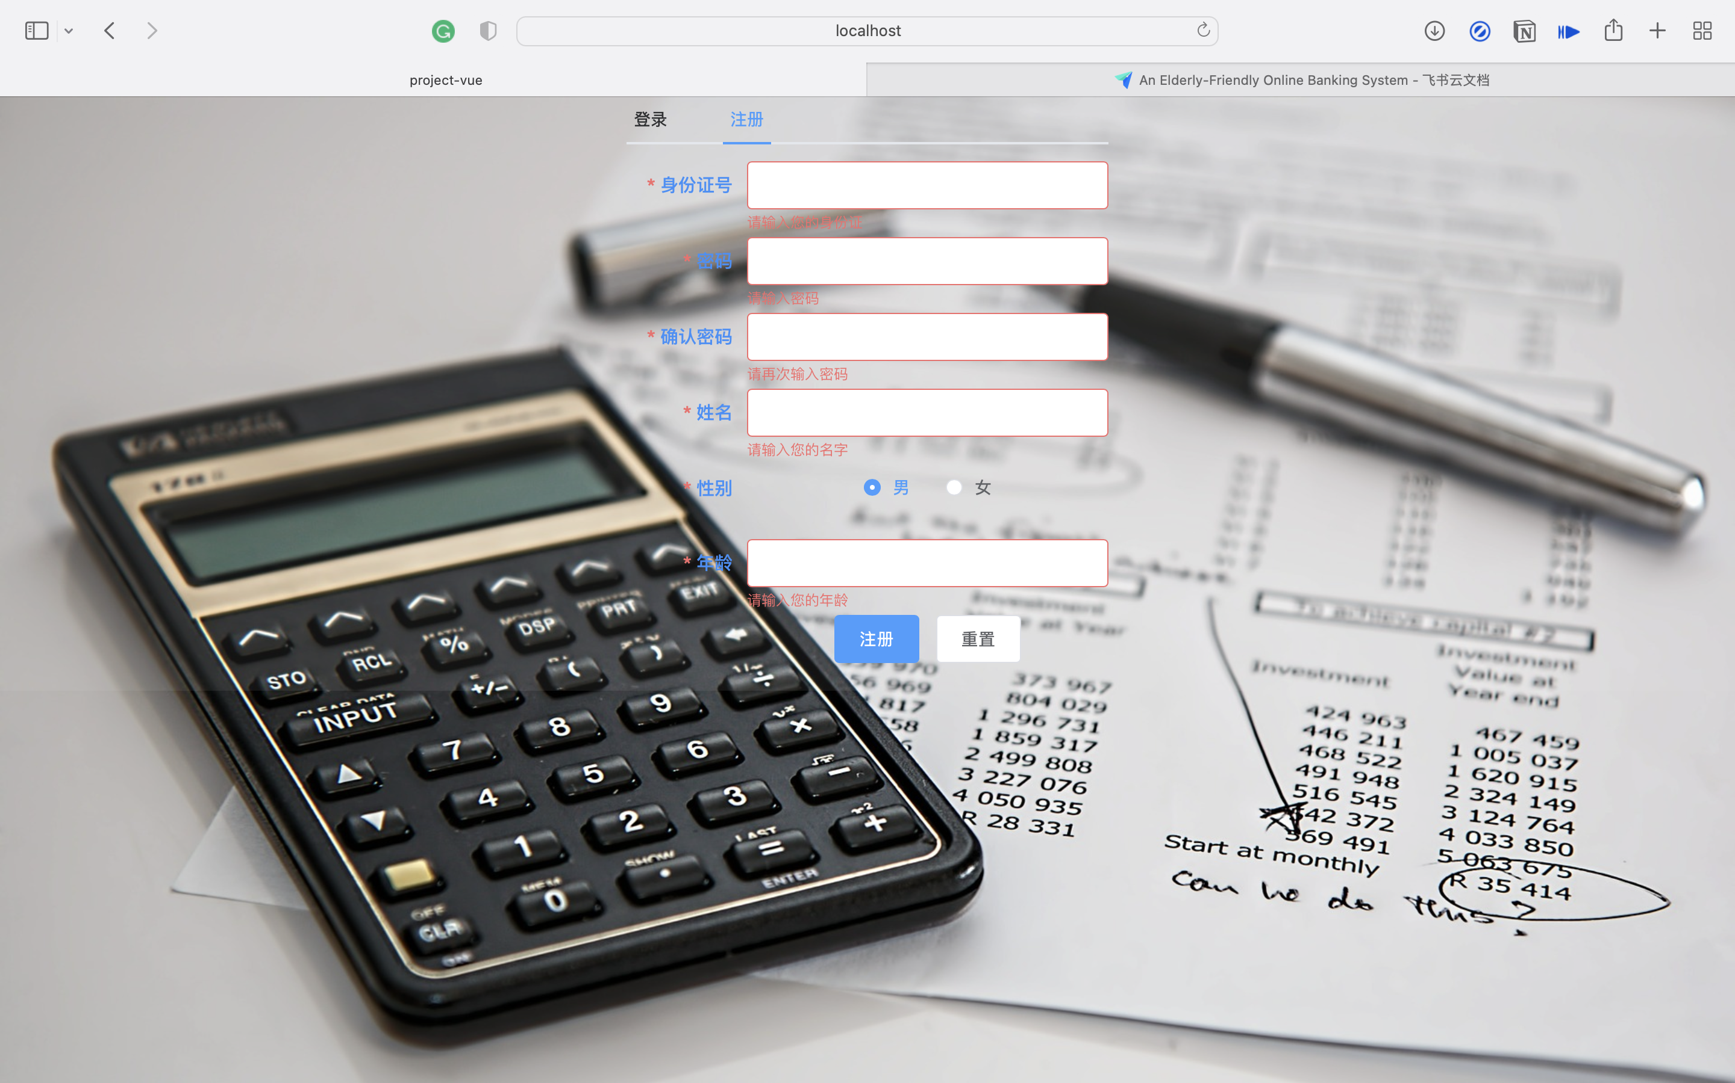

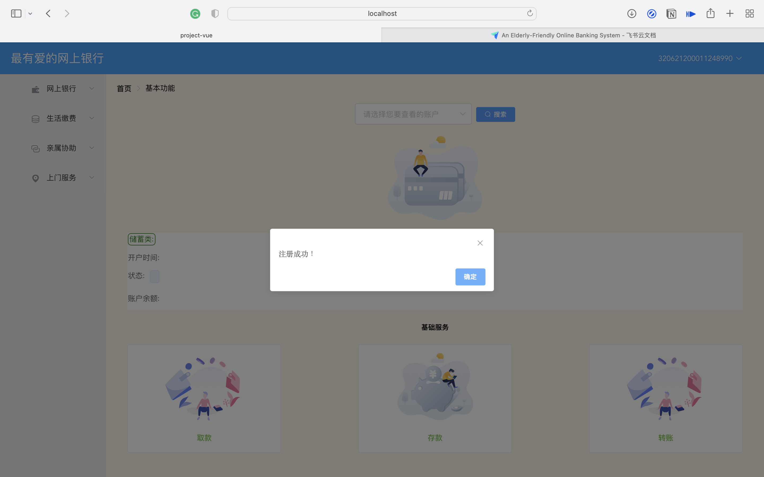

1. **User Relationship Registering**

The son or daughter input their identification number, password and their parents' information into the empty form. As usual, we set a simple rule using regular matching. After inputting their information, the system will check if the relationship has been registered. If the relationship has not been registered, the system will insert the relationship information into the database. After each submission, a message will be sent to the potential beneficiary of this action to inform him or her of the pending request.

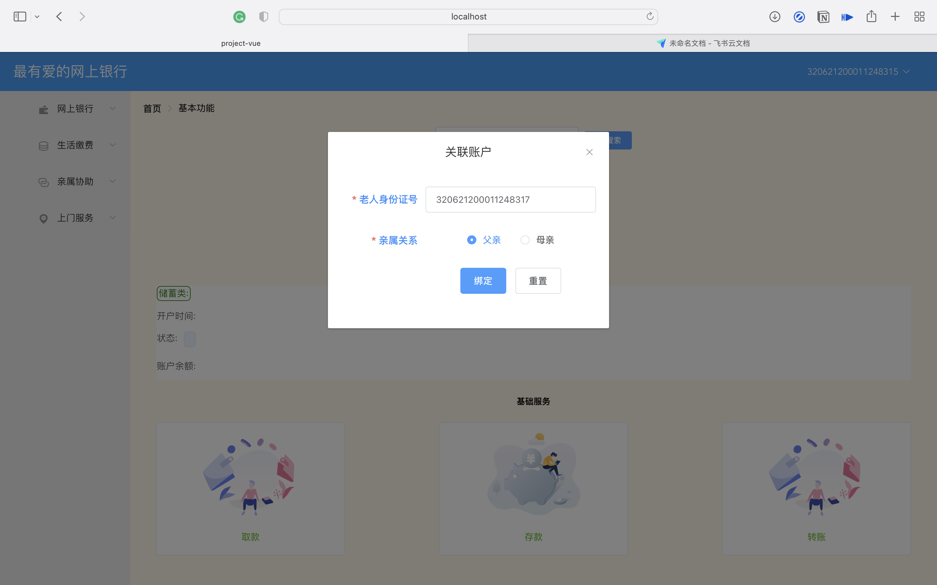

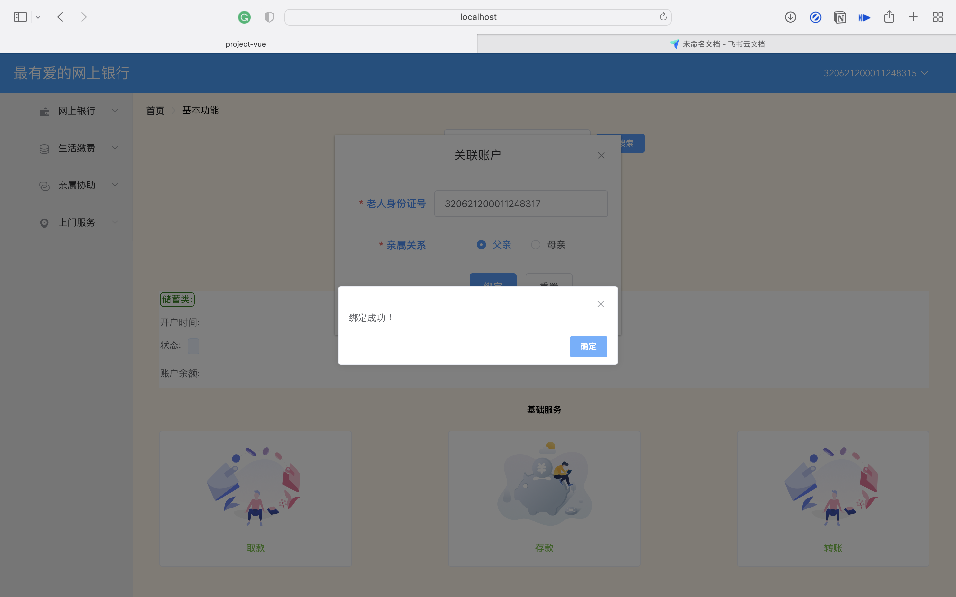

1. **User Relationship Confirming**

After the unity account completes the relationship registering, the system will send a request to parent account. If the parent logging into the system, he/she will get the request information and need to confirm. After confirmation, they can finally use the function of utility payments.

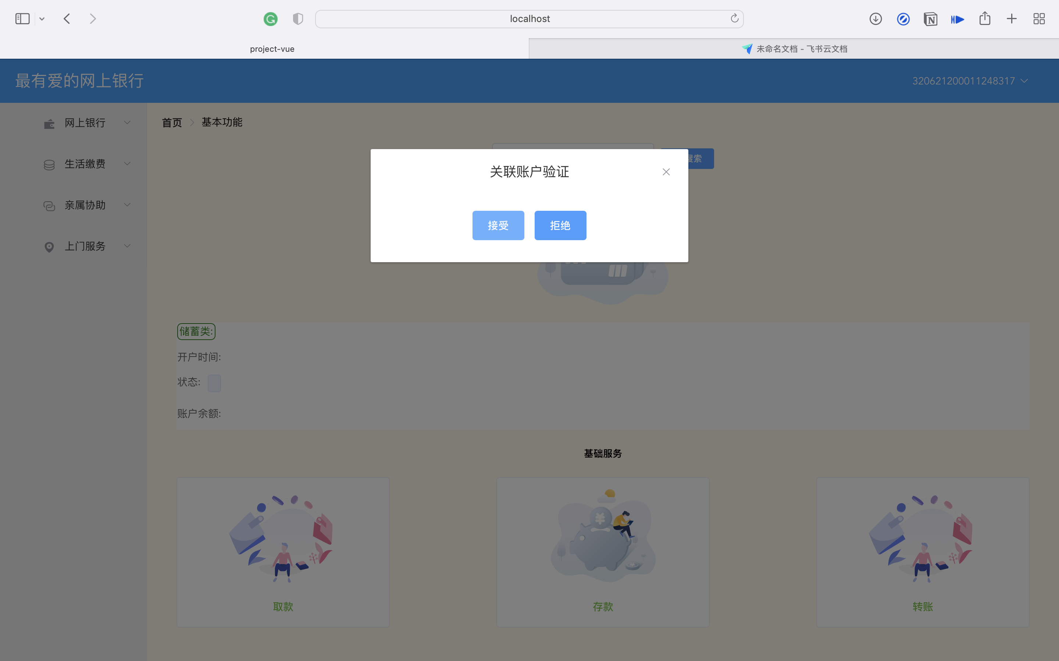

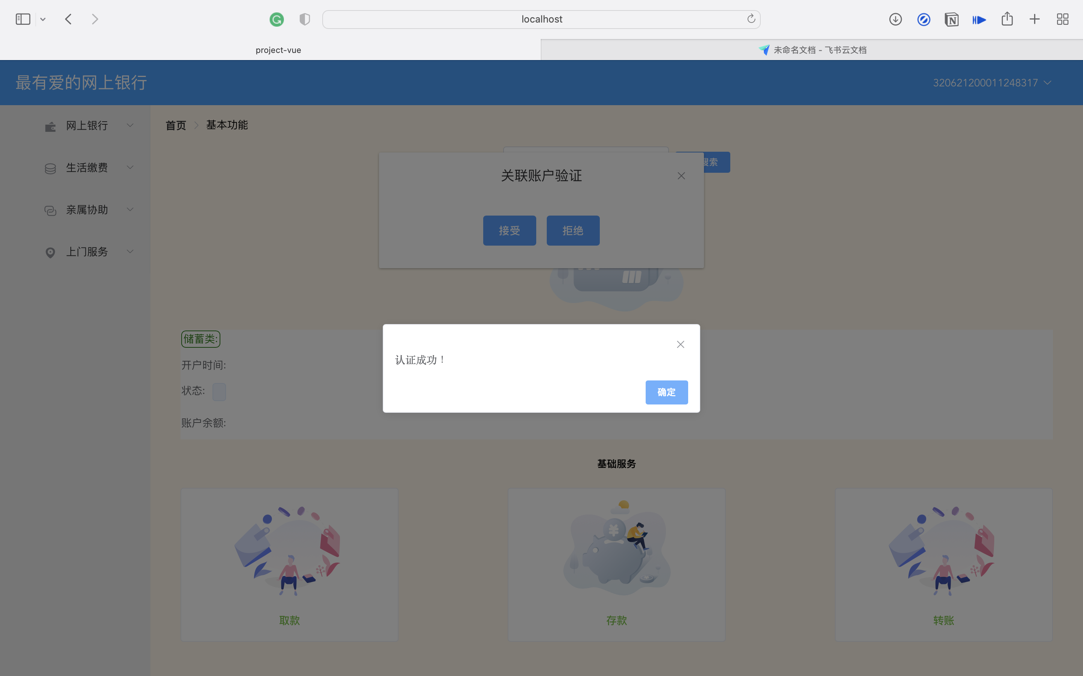

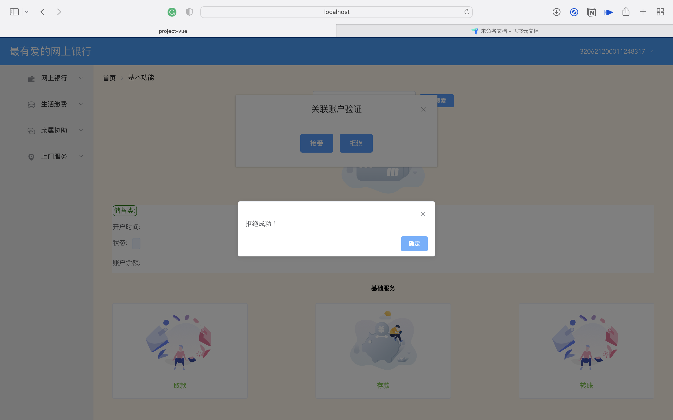

1. **Core System Functions**
2. **Money Transfer**

After logging in, the user can select the designated bank card for simple deposit and withdrawal work. Since the bank cannot be connected to the bank business, only simple changes in the bank card balance (not the core business of the system) are made here. In addition, we use it in transfer operations. The transaction ensures the atomicity of the account amount update.

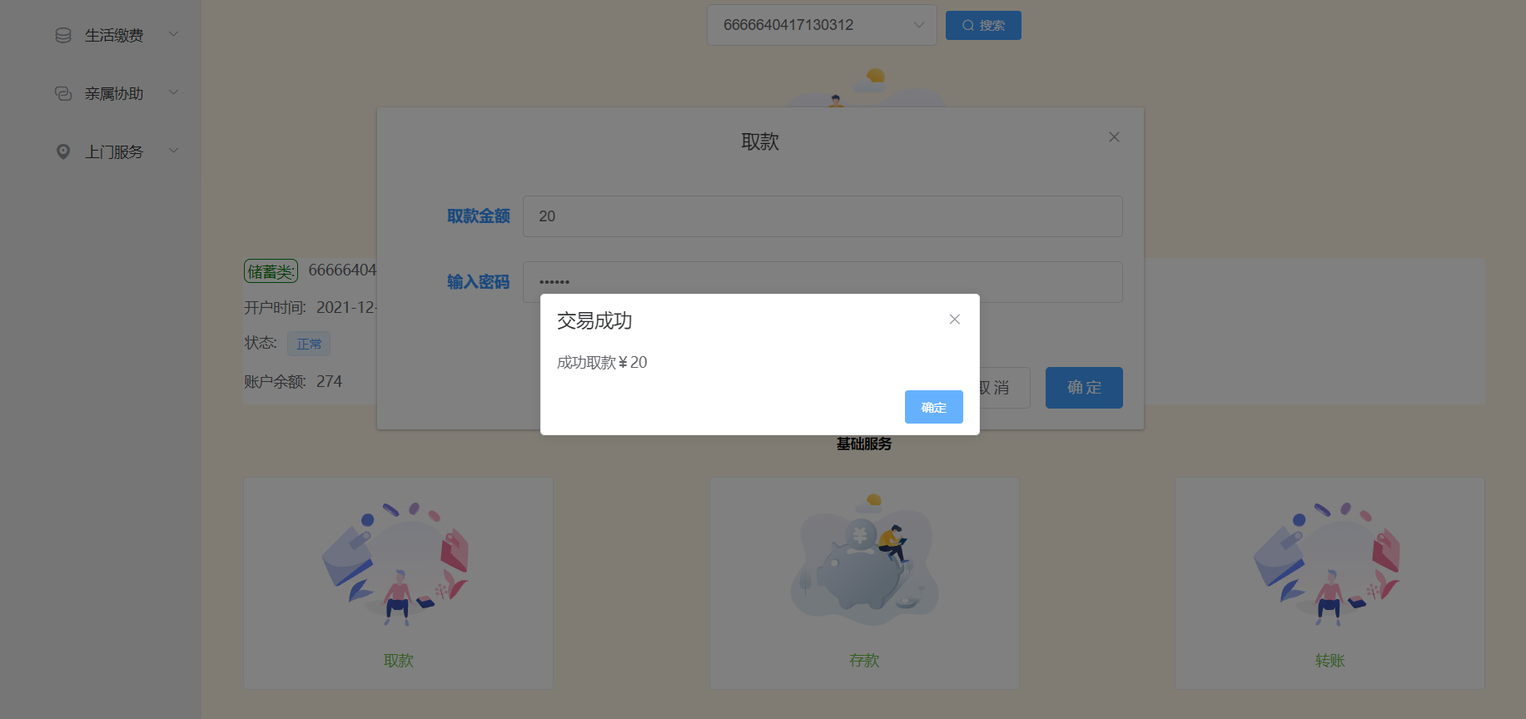

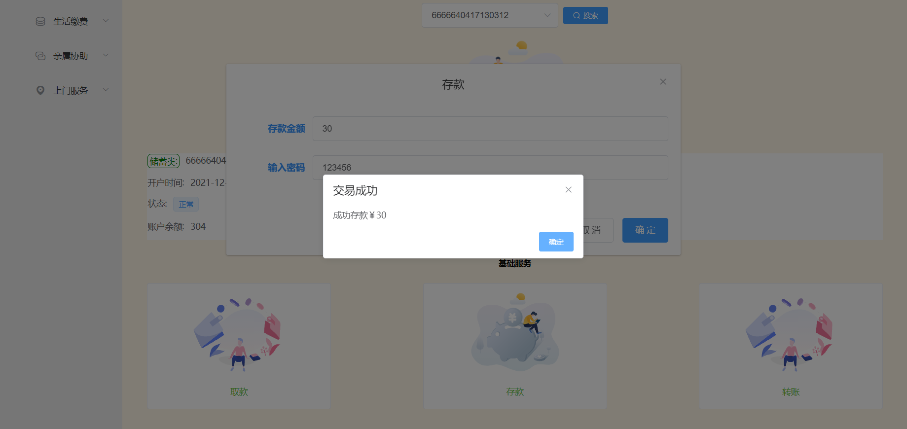

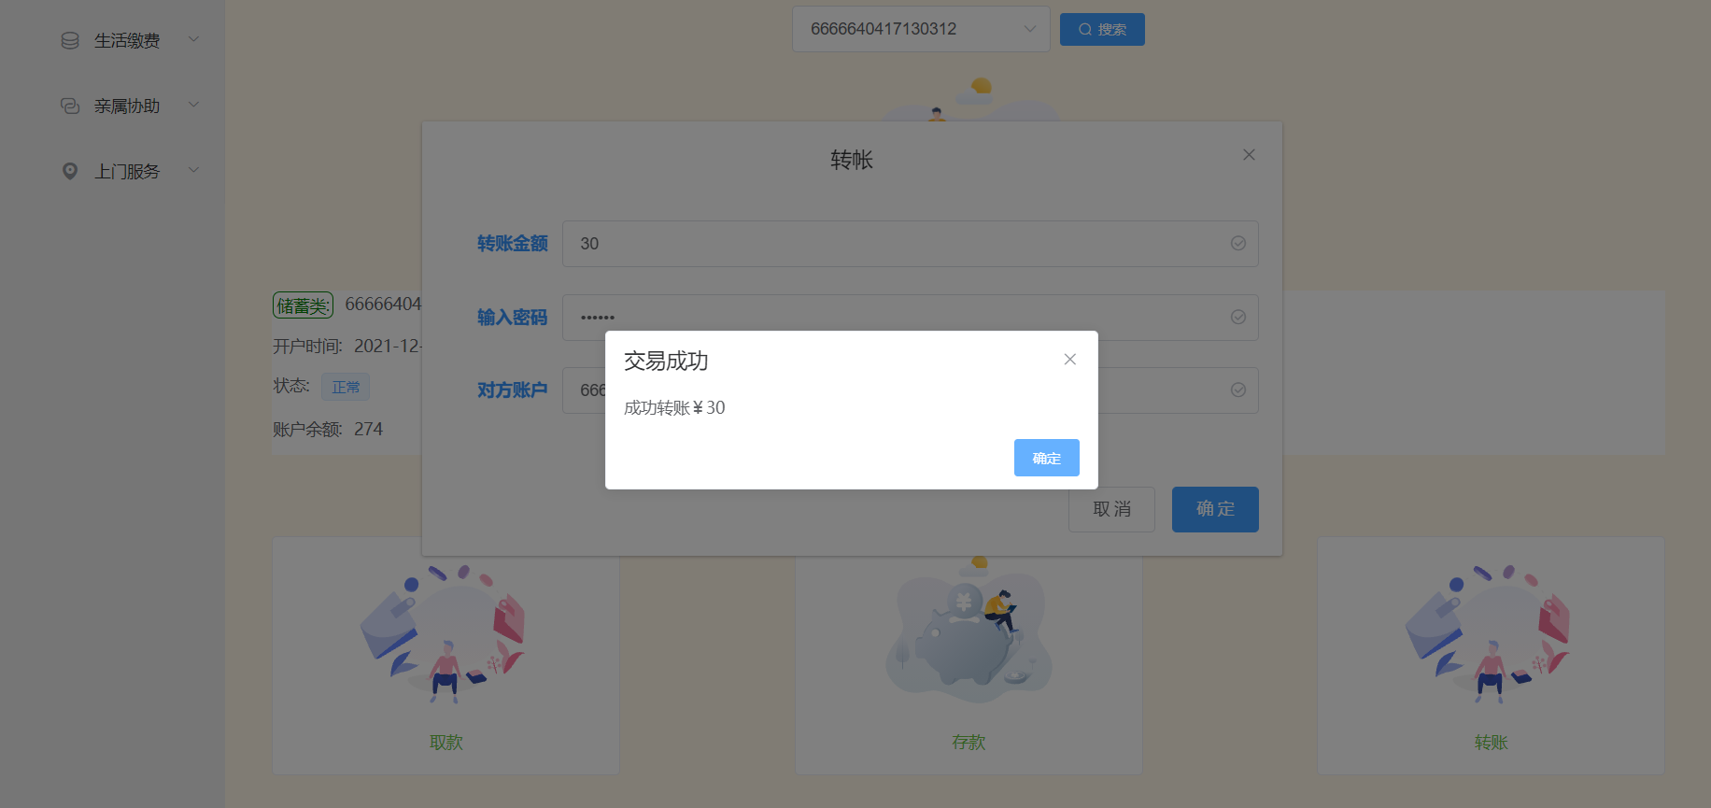

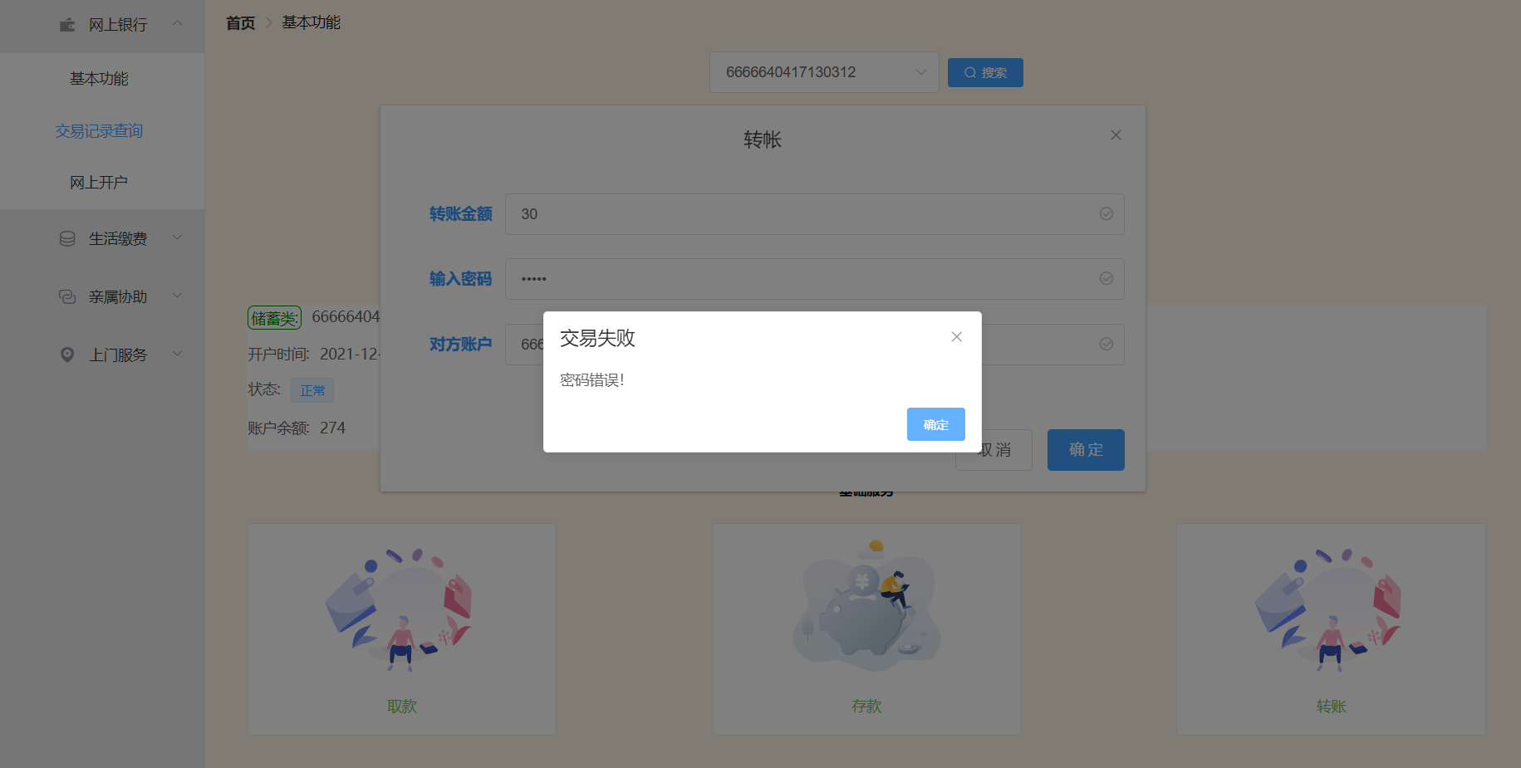

1. **Open Account**

After the user logs in, he can open a new bank account to facilitate the management and switching of multiple bank cards.

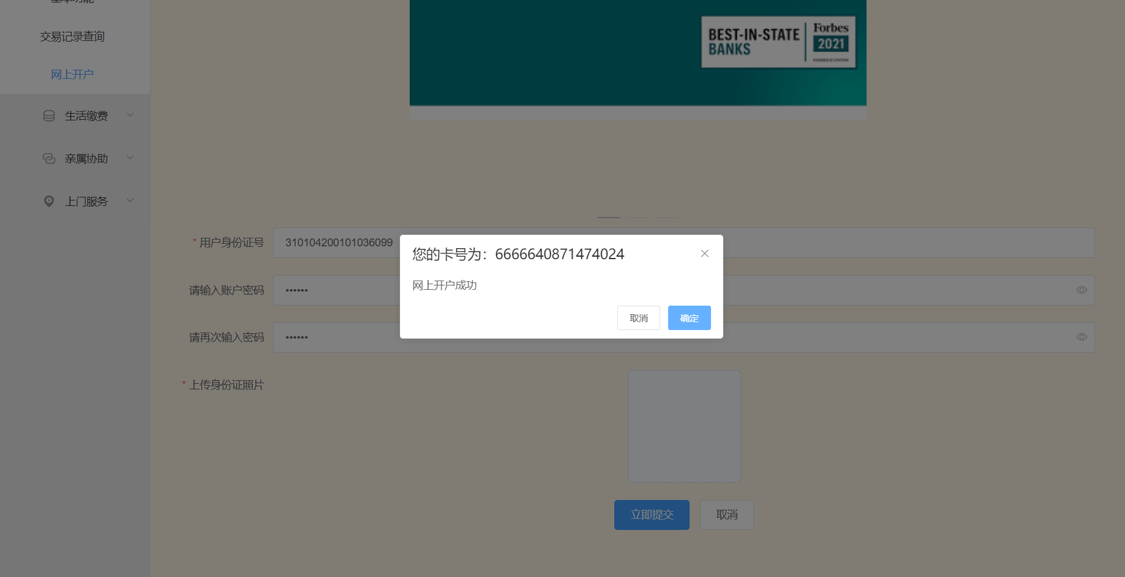

1. **Record Lookup**

All transaction behaviors of users in the system will be recorded in the database, and users can view past transaction records at any time. The main types of transactions are: transfer, deposit, withdrawal, water bill payment, electricity bill payment, gas bill payment.

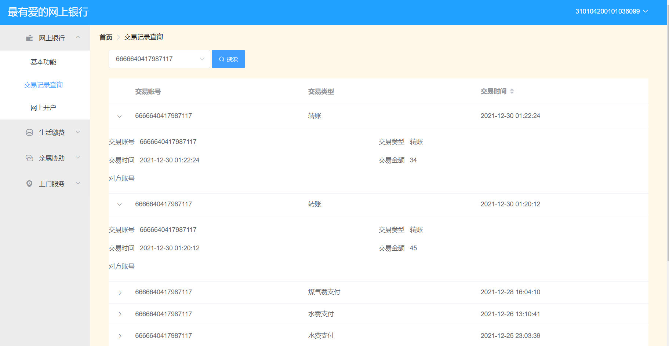

1. **Utility Payments**

After a user is correctly logged into the system, he or she can then choose utility payment function from the navigation bar on the left. Then, the user needs to input the information required to proceed with the utility bill payments process.

1. **Water Bill Payment**

To successfully pay a water bill, a user is required to give a valid ID number of whom the bill belongs to. Then, the user needs to give a valid bank account with enough balance and input the correct password of that account. Finally, the user needs to choose the type of bill he or she is going to pay from the list. In this case, the user should choose Water Bill.

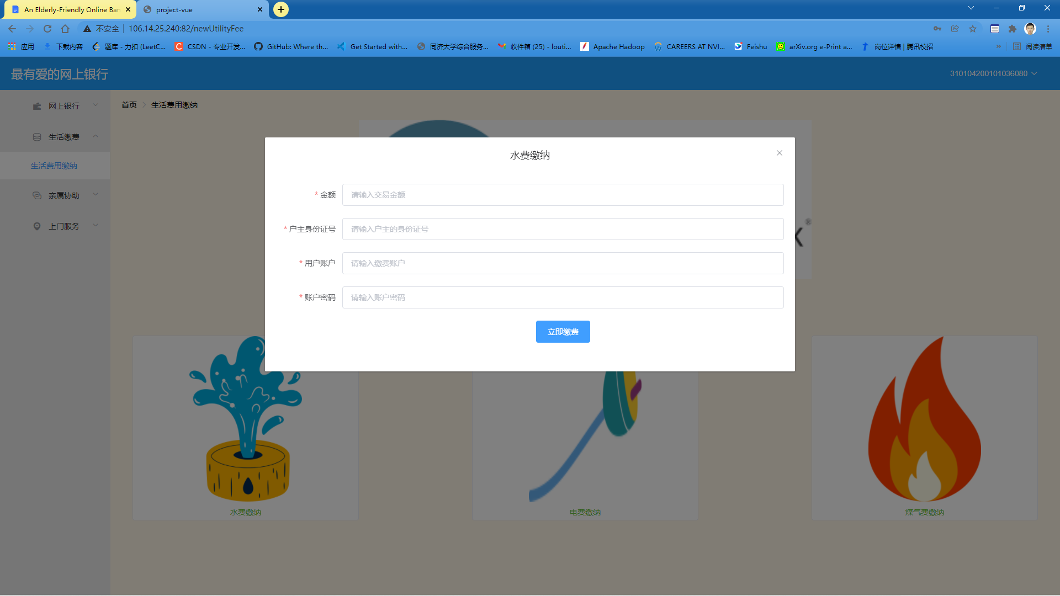

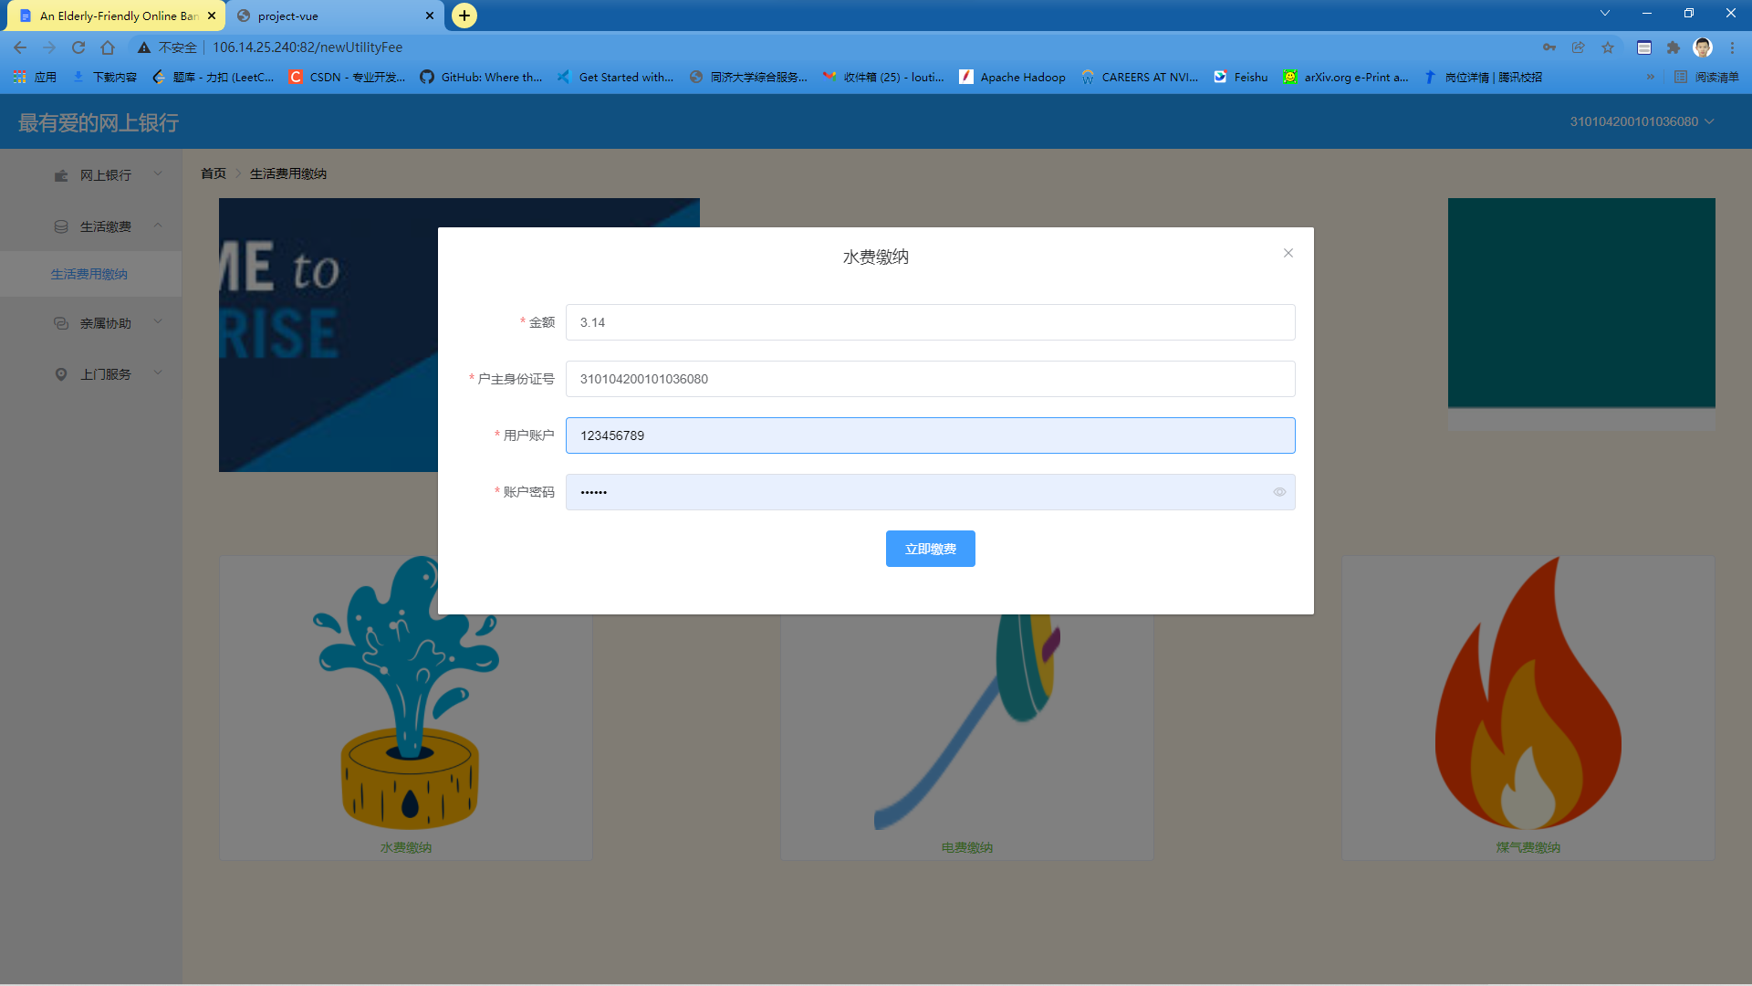

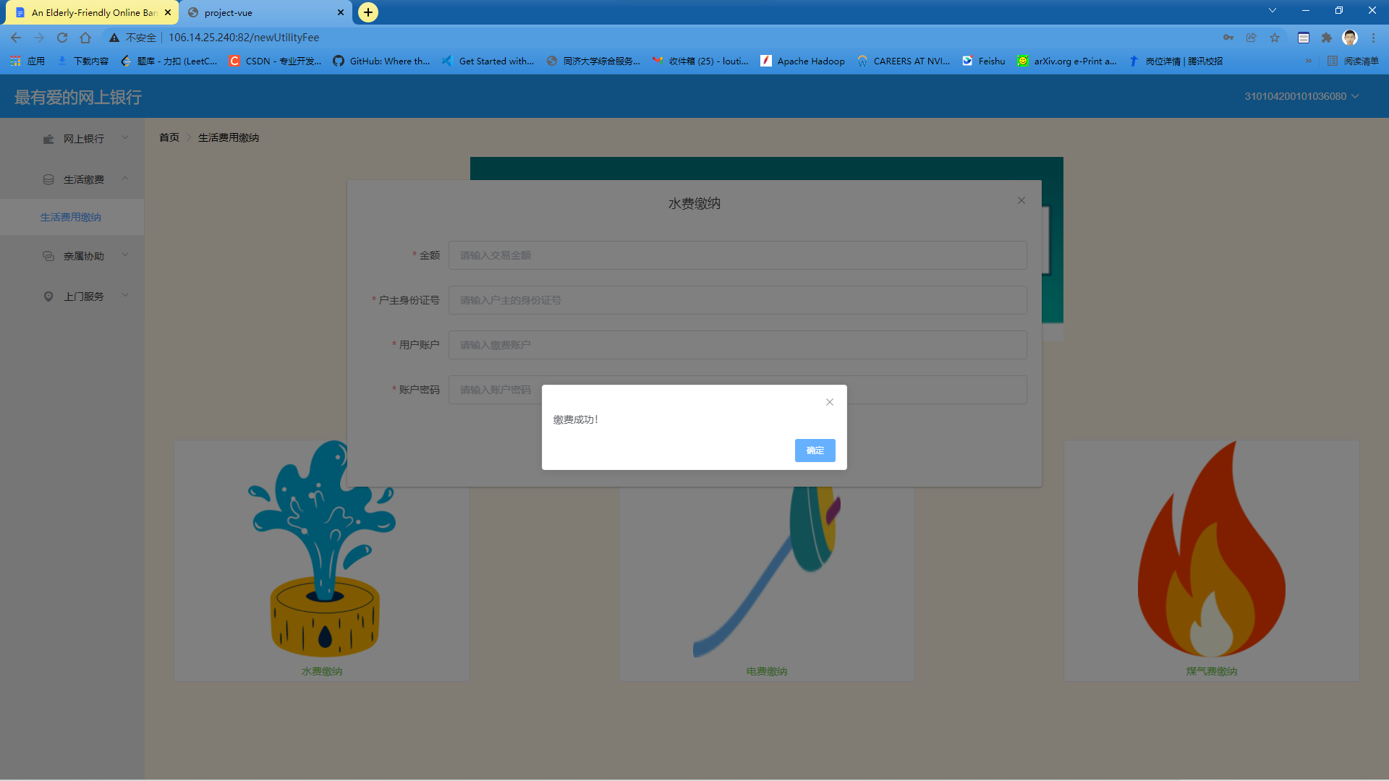

1. **Electricity Bill Payment**

To successfully pay an electricity bill, a user is required to give a valid ID number of whom the bill belongs to. Then, the user needs to give a valid bank account with enough balance and input the correct password of that account. Finally, the user needs to choose the type of bill he or she is going to pay from the list. In this case, the user should choose Electricity Bill.

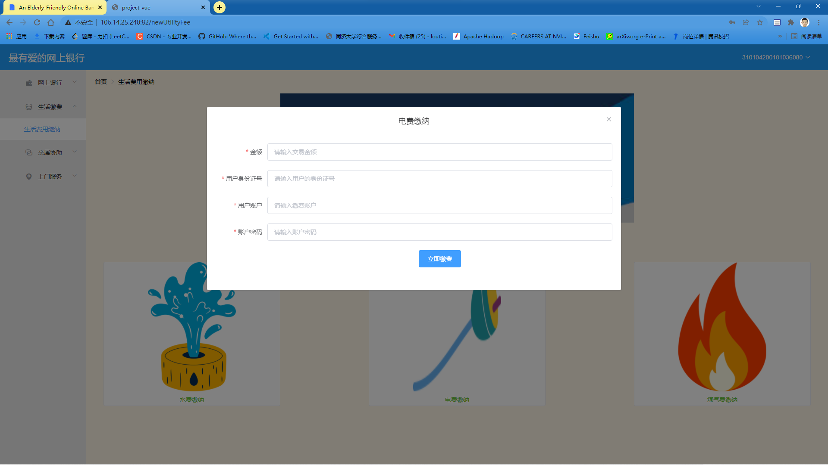

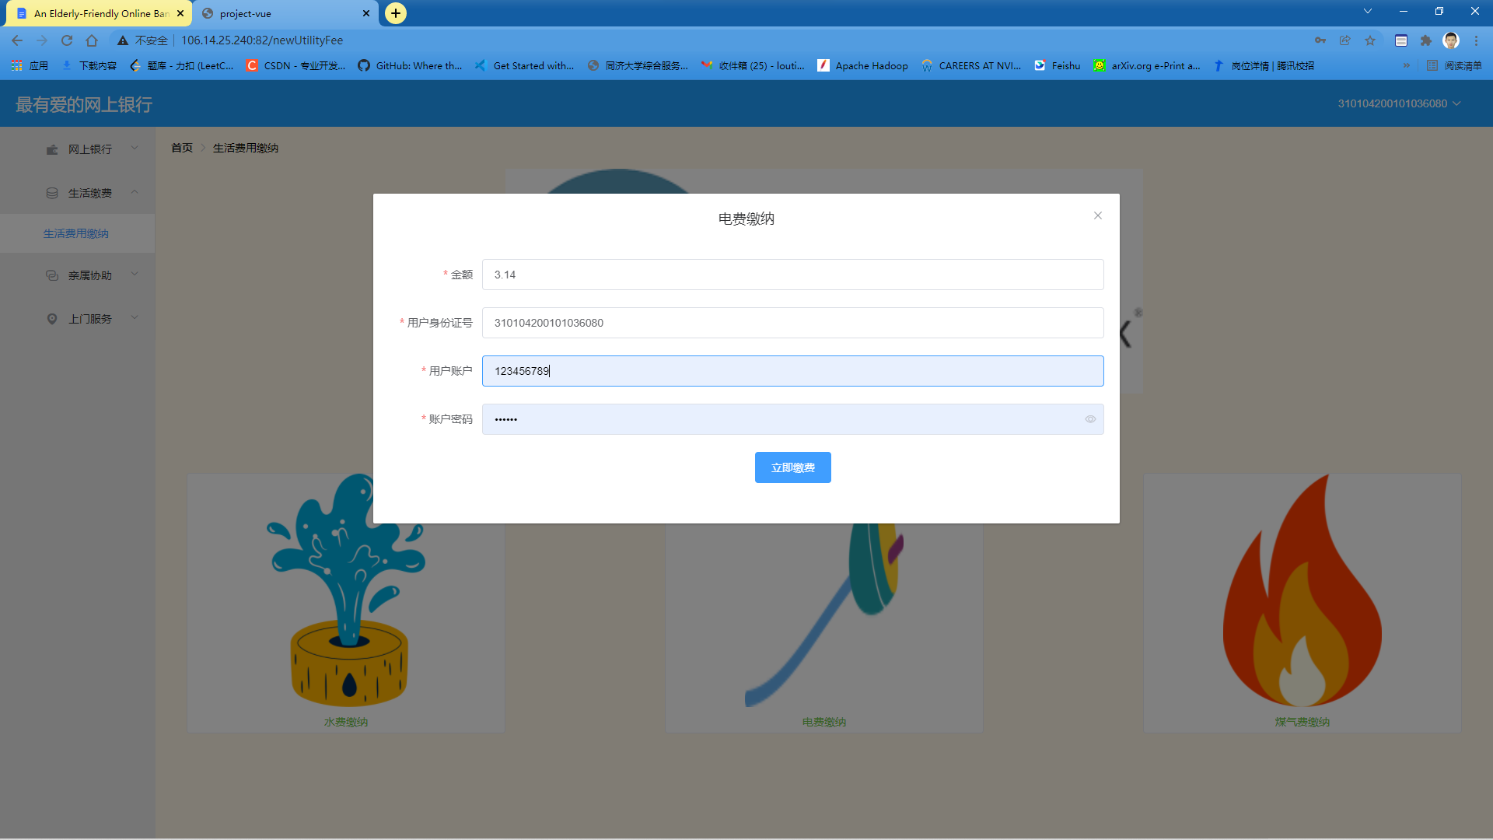

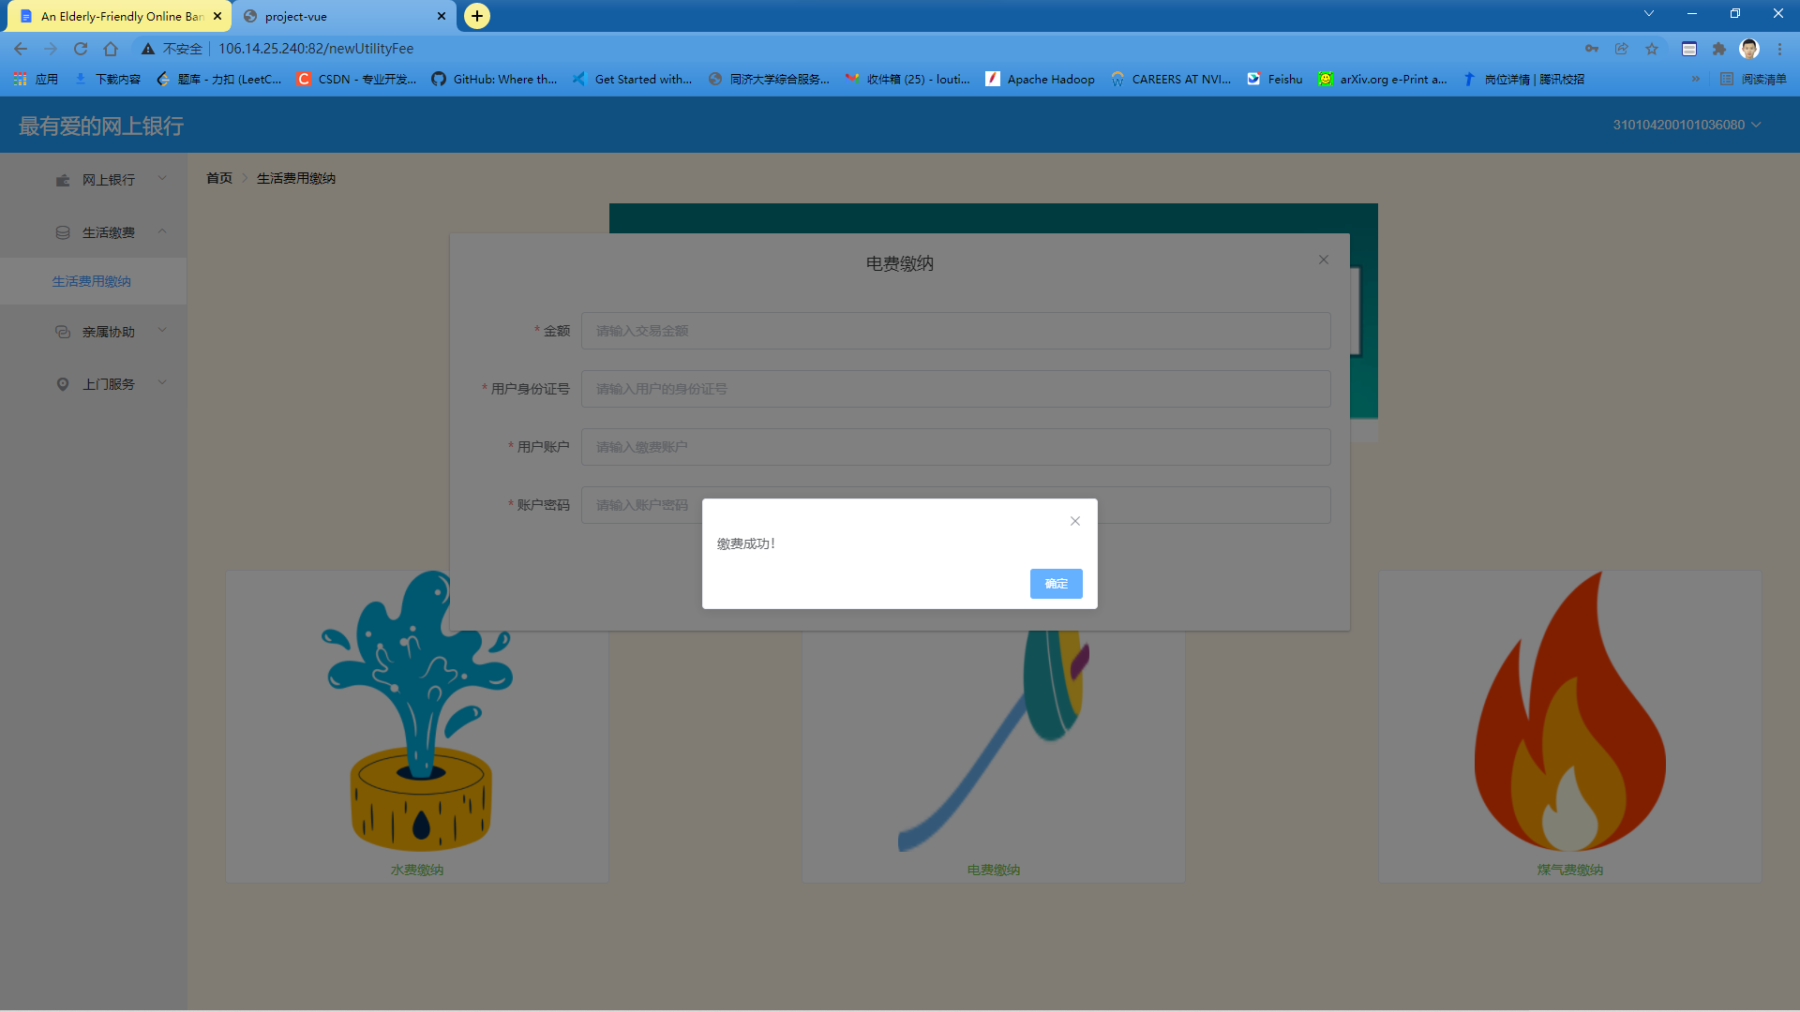

1. **Gas Bill Payment**

To successfully pay a gas bill, a user is required to give a valid ID number of whom the bill belongs to. Then, the user needs to give a valid bank account with enough balance and input the correct password of that account. Finally, the user needs to choose the type of bill he or she is going to pay from the list. In this case, the user should choose Gas Bill.

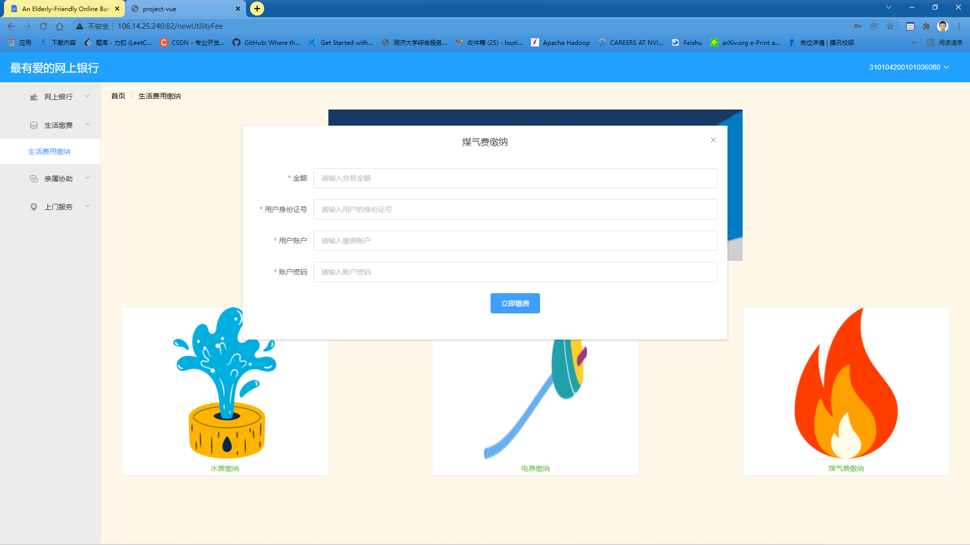

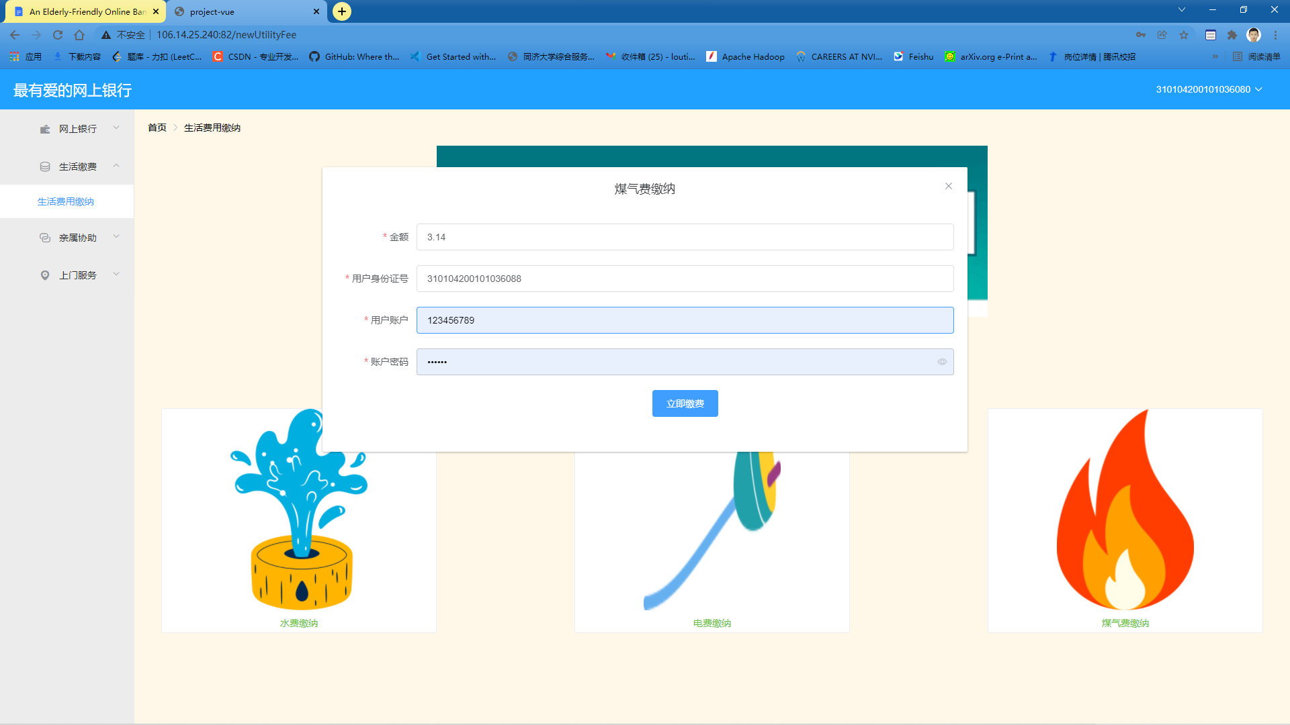

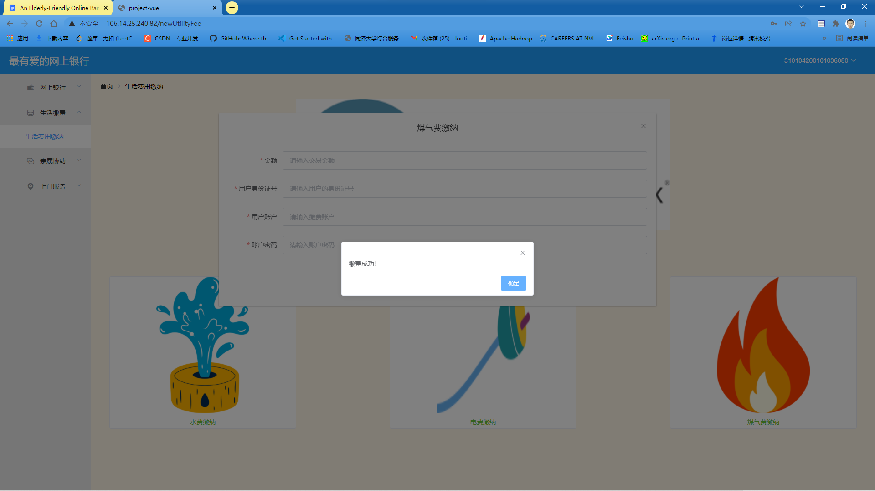

1. **Assistance Requests**
2. **Launching an Assistance Request**

In order to launch assistance requests successfully, a user can register one and only one relative of his or her who needs help to perform online banking activities.

A user can launch assistance requests for their registered relatives. The type of assistance requests that can be launched in our system are: utility bill payment request, money transferring request and open account assistance request.

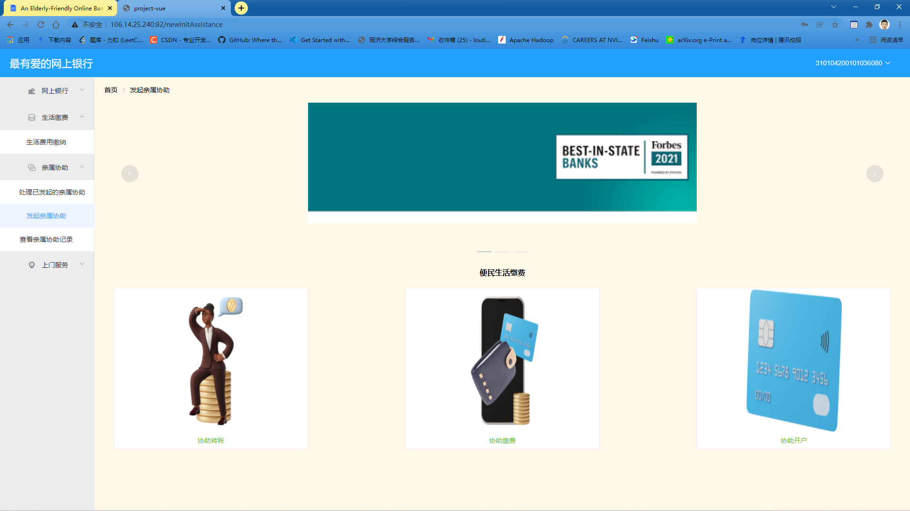

1. **Launching a new utility bill payment assistance request**

If a user wants to help his or her registered relative to pay an existing utility bill, i.e. Water bill, electricity bill and gas bill. The user is required to enter the identification ID of the bill owner and is also the helper's duty to provide a valid bank account with enough balance left and the correct password to pay for this bill. However, if the helper is not registered for account association with the ID number he or she has just entered, the system will block this operation.

After the user has submitted the request, our system will automatically send a message to the user being helped to inform him or her that an assistance request has been launched and is pending approval or rejection. The bill will only be paid if the request is approved by the designated relative.

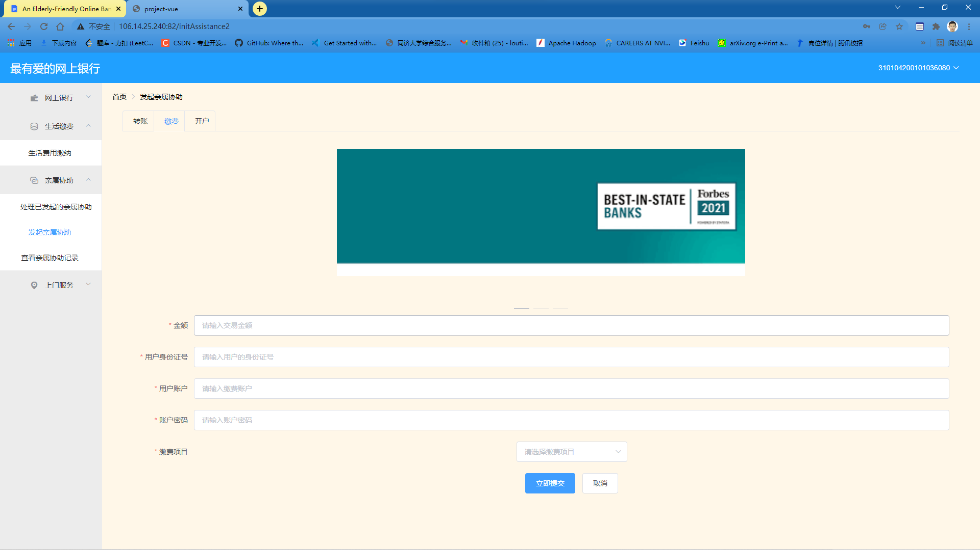

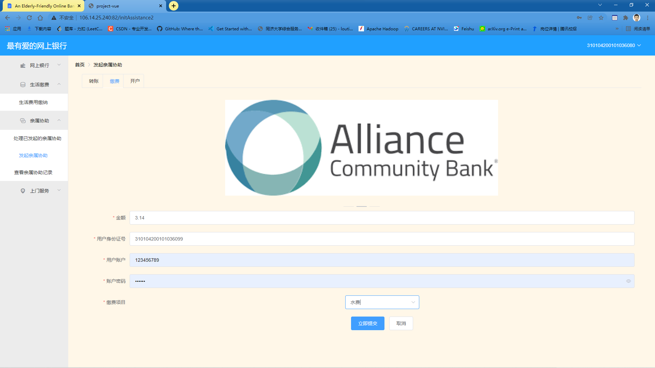

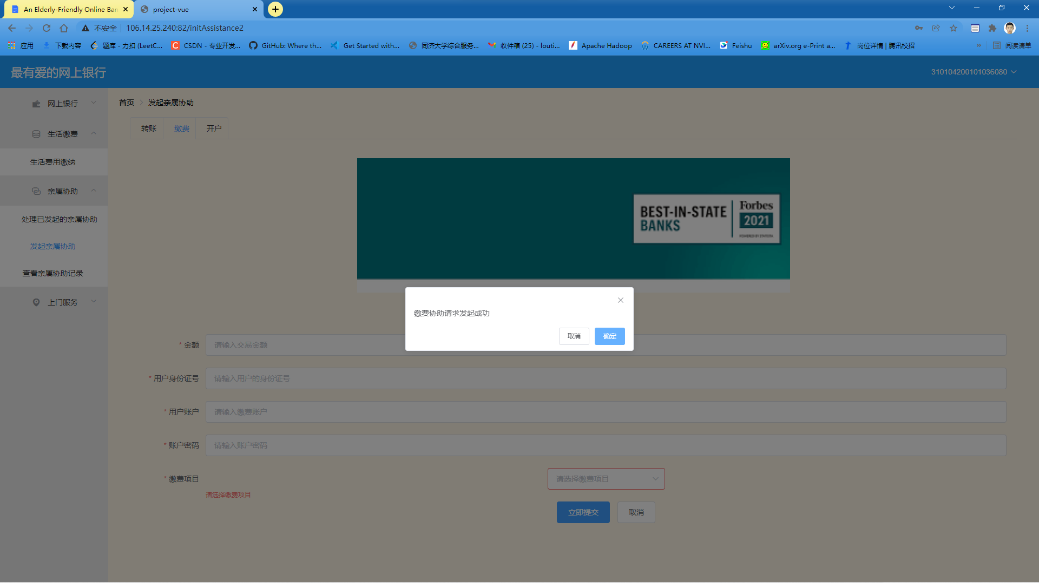

Operation blocked by our system: unregistered association.

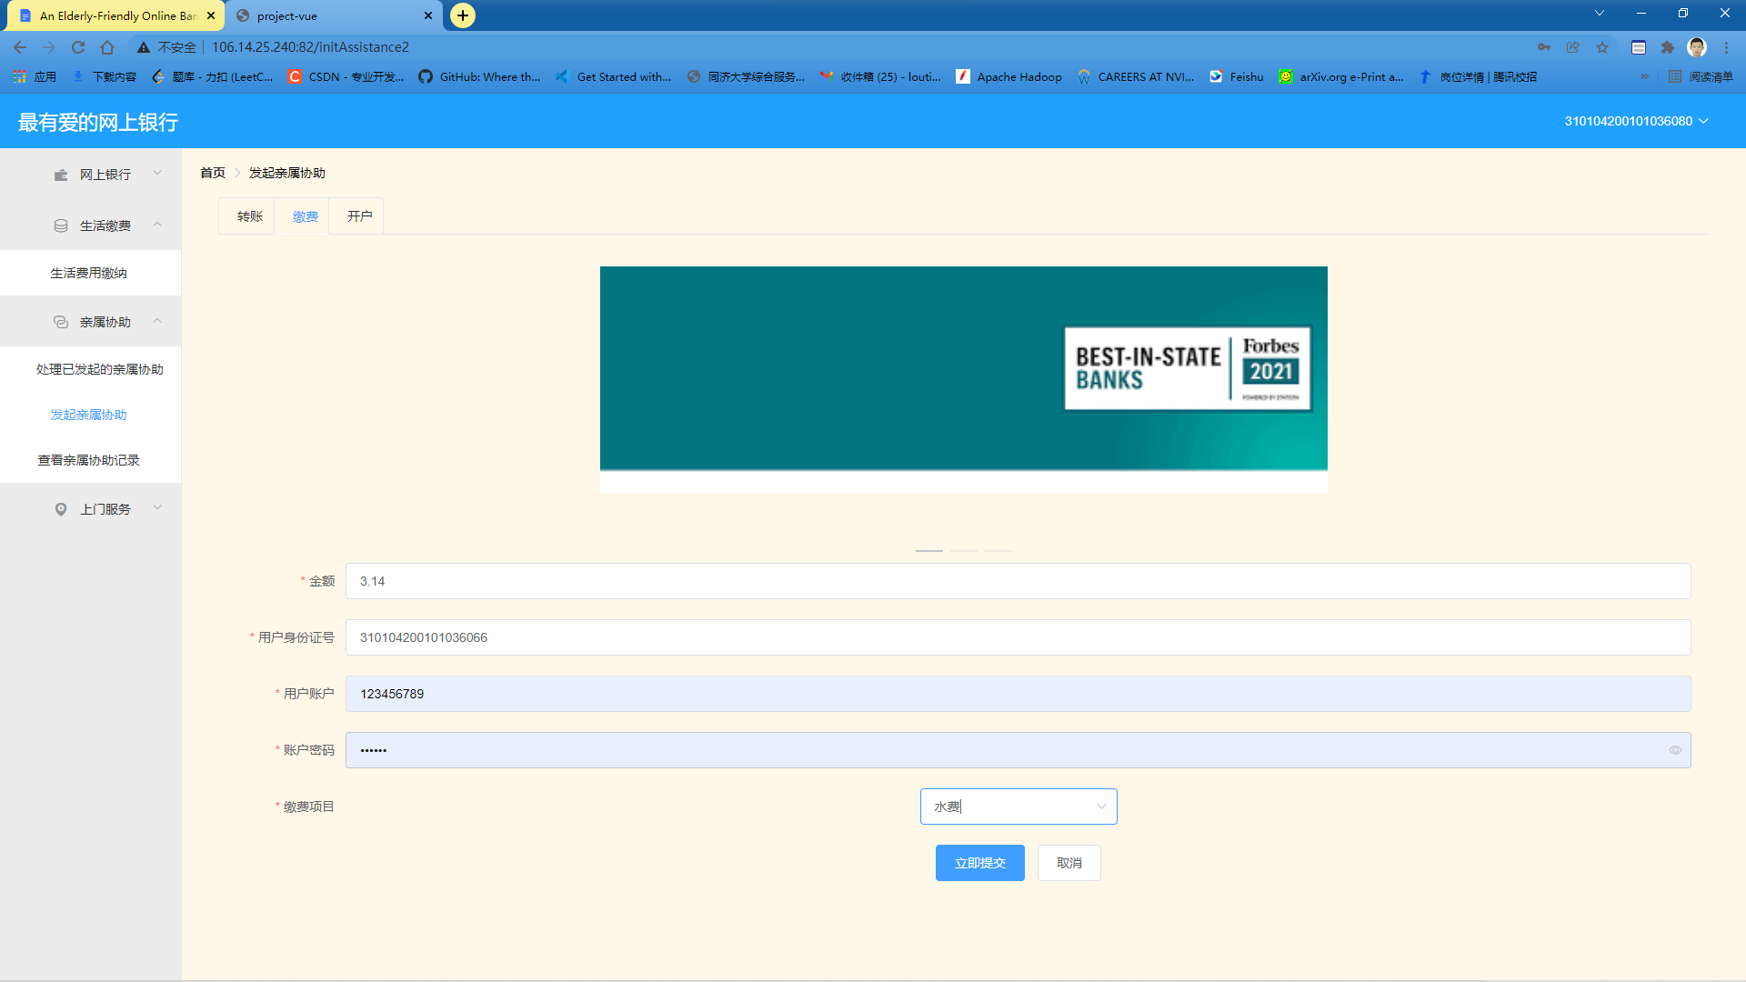

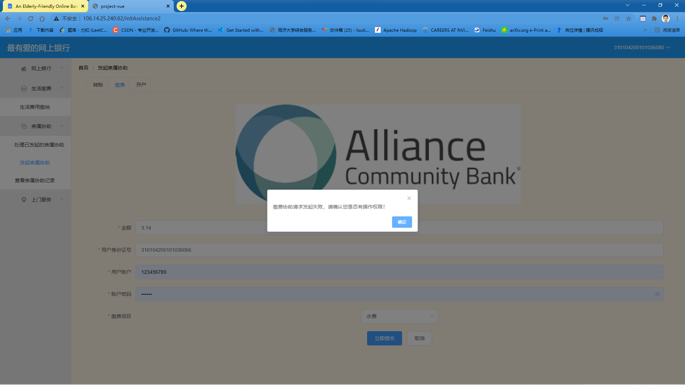

1. **Launching a new money transferring assistance request**

If a user wants to help his or her registered relative to transfer money from one existing bank account to another, the user who is launching this assistance request is required to give the correct identification ID of the relative he or she is helping. Also, two valid bank account numbers must be provided, along with the password for the account that is transferring the money out. However, if the helper is not registered for account association with the ID number he or she has just entered, the system will block this operation.

After the user has submitted the request, our system will automatically send a message to the user being helped to inform him or her that an assistance request has been launched and is pending approval or rejection. The money can only be transferred if the request is approved by the designated relative.

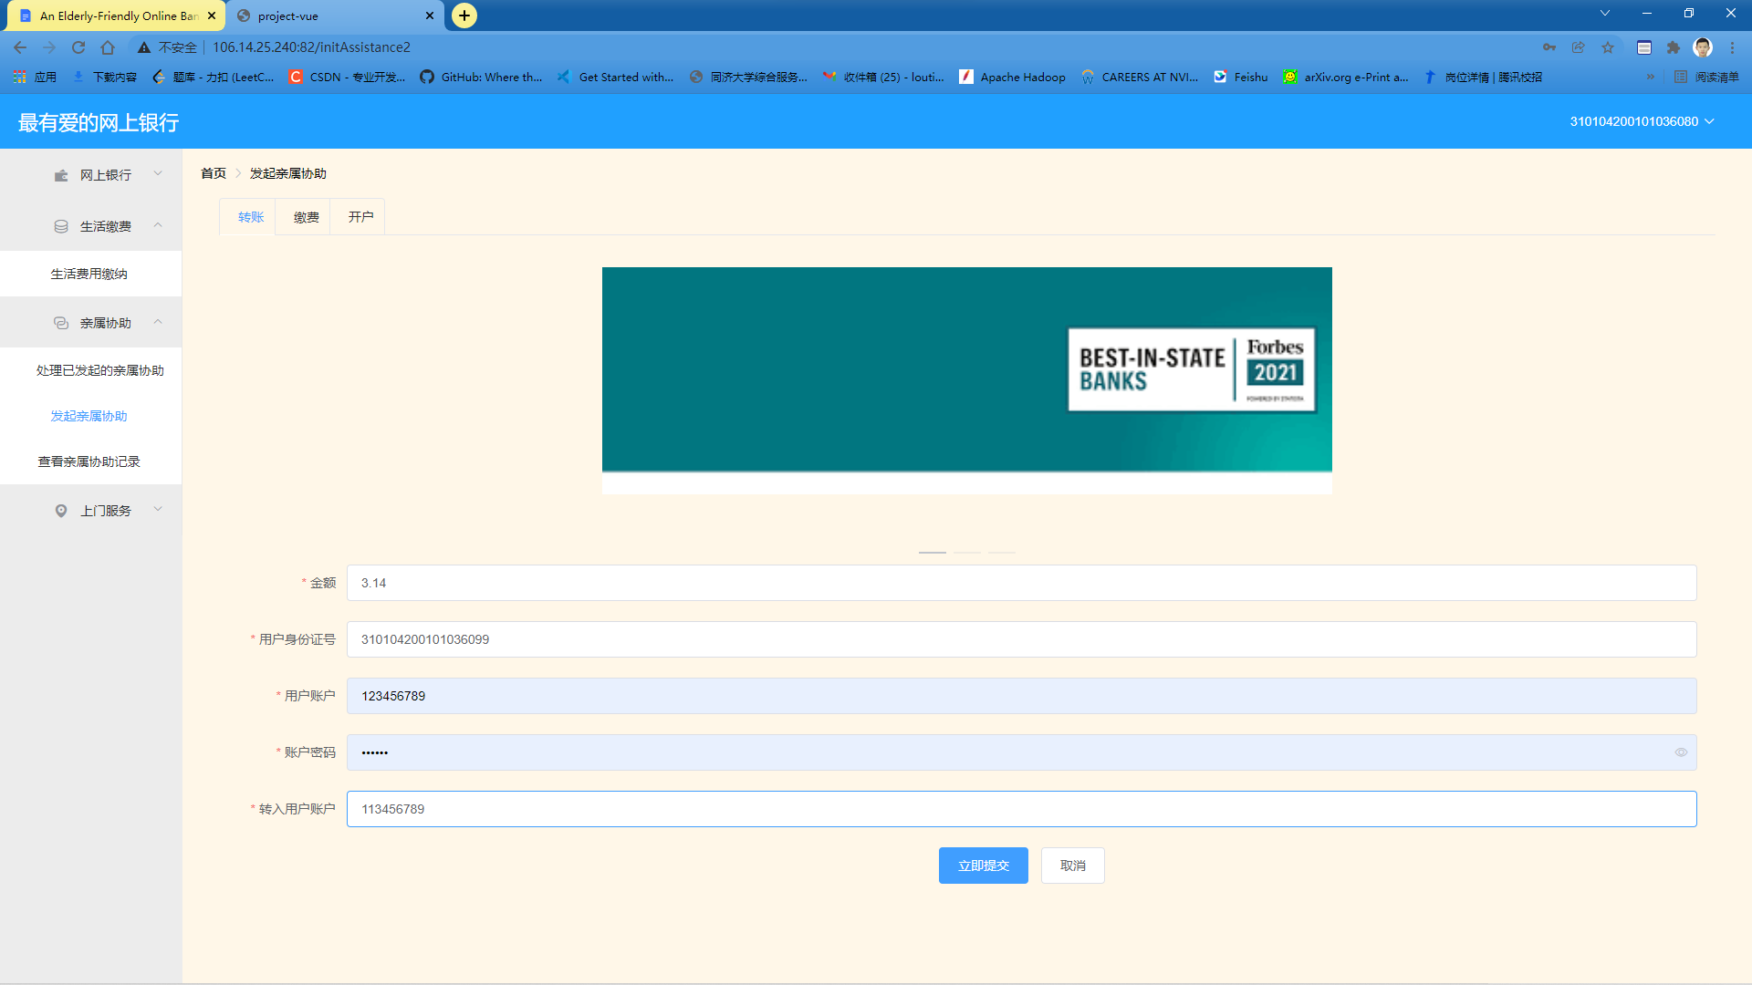

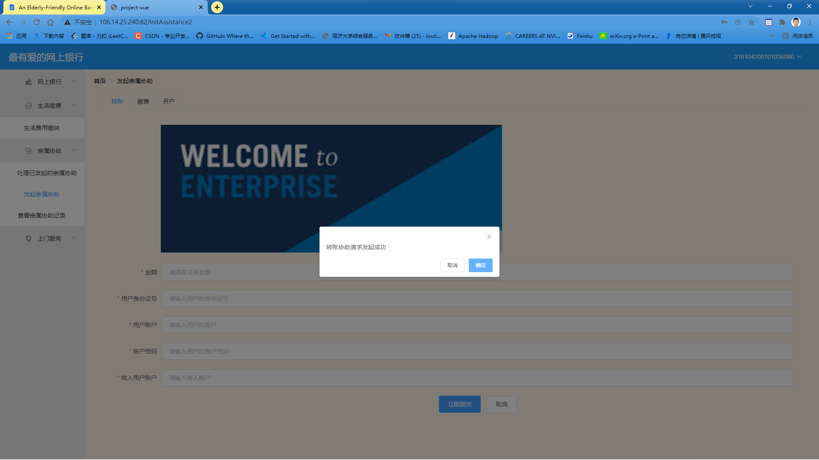

1. **Launching a new open account assistance request**

If a user wants to help his or her registered relative to open a new deposit account at our bank, the user who is making this request is responsible for providing the correct identification ID of the actual account owner (which is the beneficiary of this assistance request). Also, the password set for this account needs to be entered twice for confirmation. However, if the helper is not registered for account association with the ID number he or she has just entered, the system will block this operation.

After the user has submitted the request, our system will automatically send a message to the user being helped to inform him or her that an assistance request has been launched and is pending approval or rejection. The account will only be actually open if the request is approved by the designated relative.

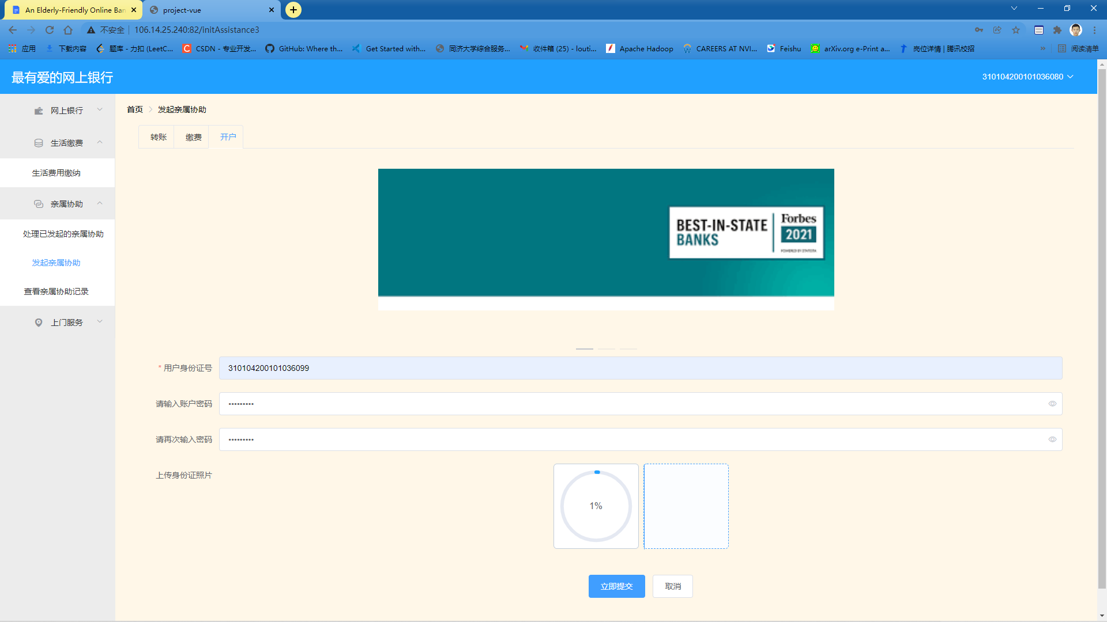

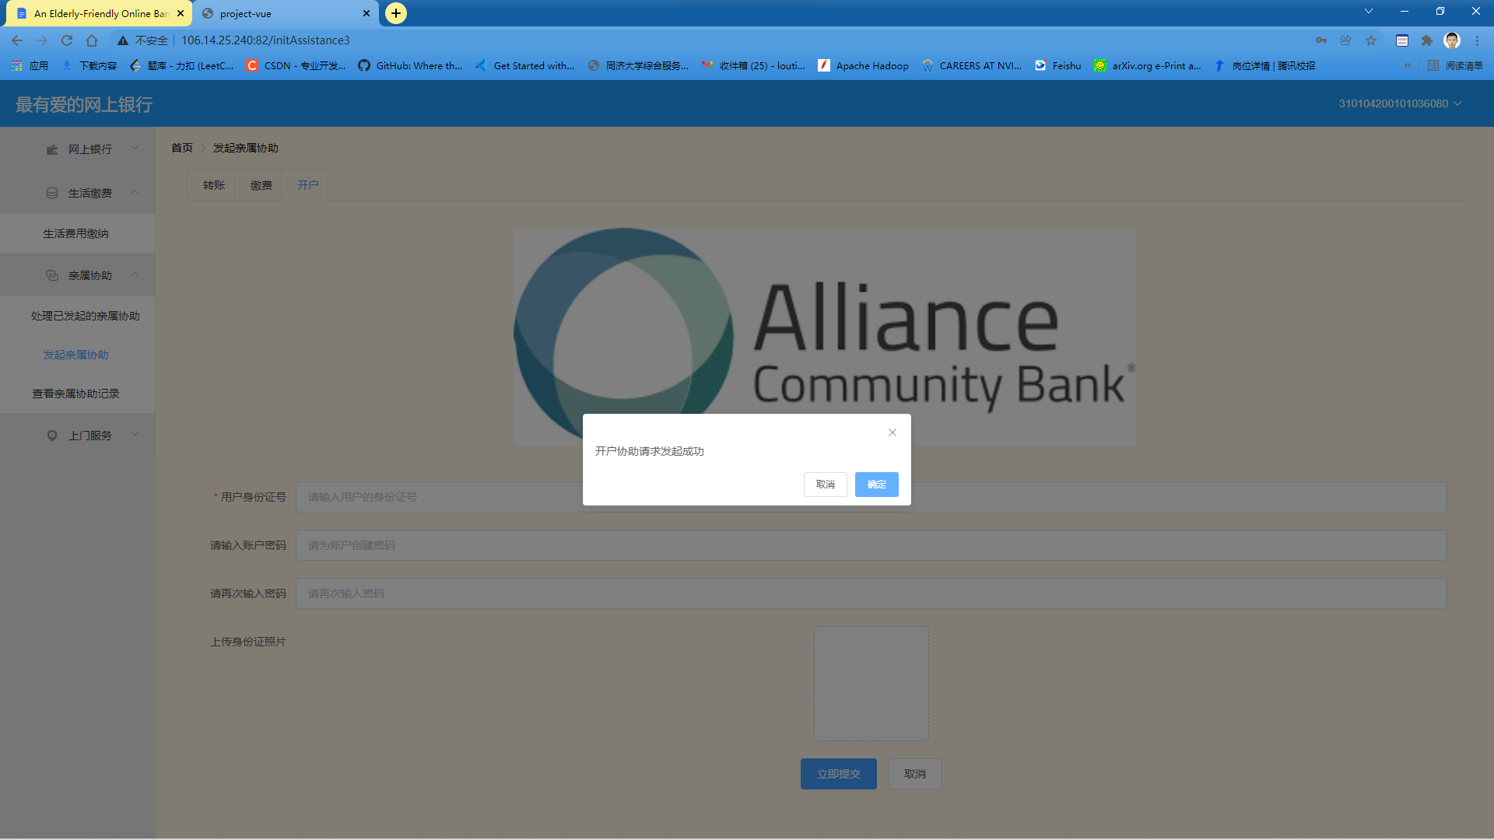

1. **Process Assistance Requests Generated by Desginated Relatives**

A user can view and process all the assistance requests launched for him. Every time the user's registered relative has finished a new assistance request for the user, a message bar will appear on top of the page, informing the user that a new assistance request has been launched, and that he or she should choose to accept or decline this request.

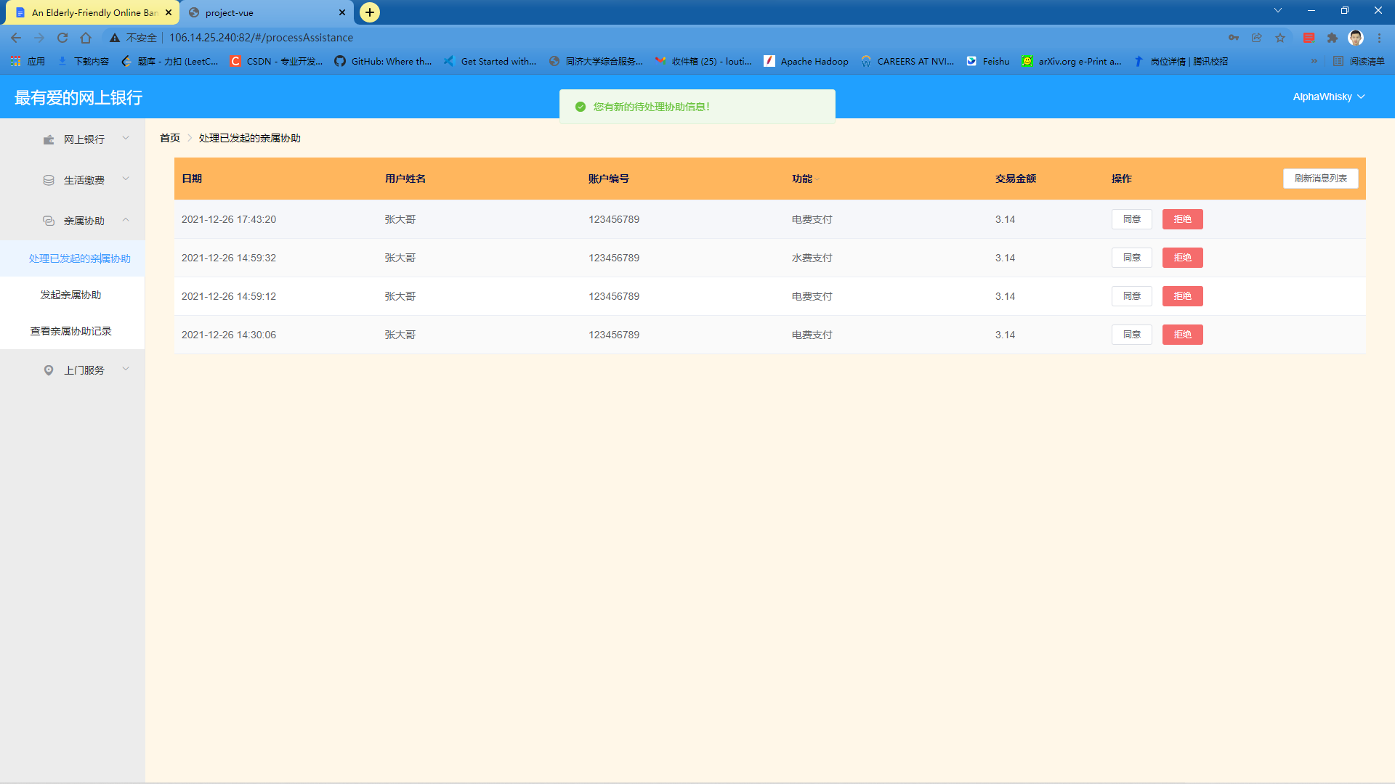

Should the user choose to accept an assistance request, the system function included in that assistance request will be actually conducted with the necessary information provided by the user's registered relative. In a word, the user being helped will only need to press a button to complete various tasks.

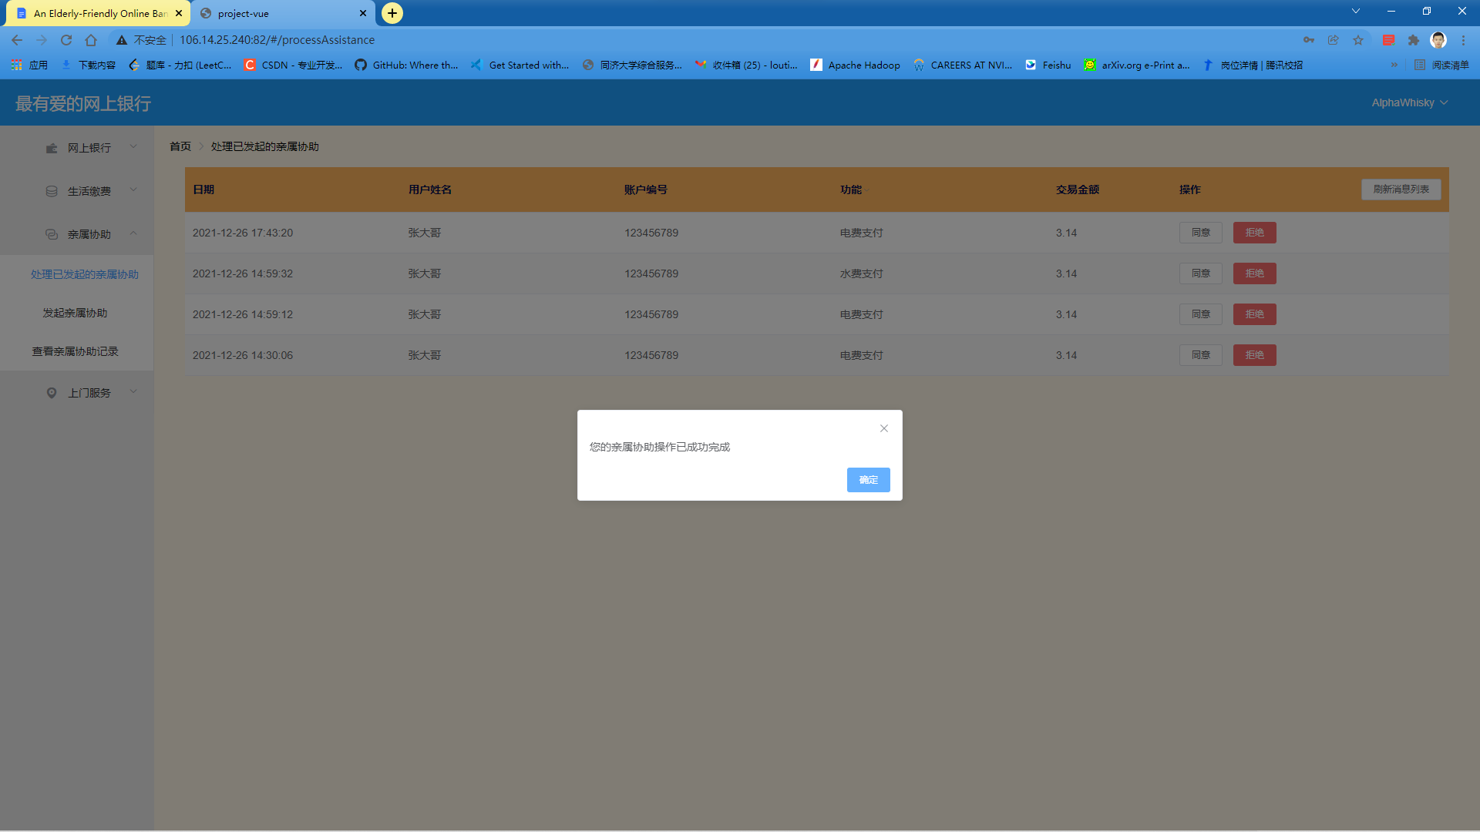

However, if the user being helped finds out that the assistance request is not launched according to his or her intention or there is faulty information included in this request that might lead to unsuccessful conduction of system functions, he or she could simply decline this assistance request. The system function included in a declined assistance request will never be actually performed.

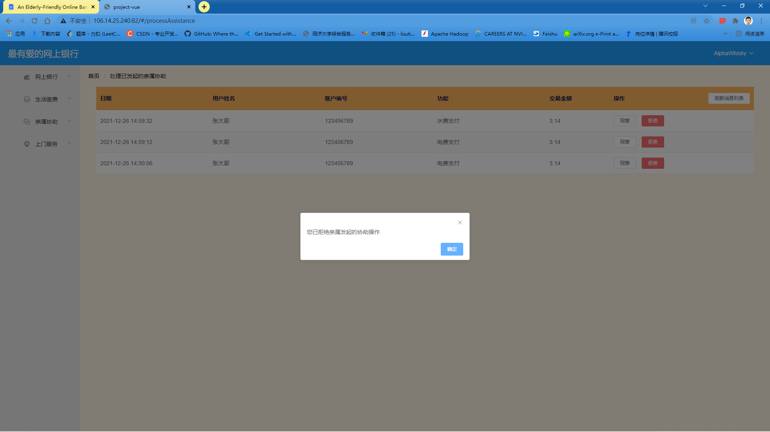

Also, for the convenience of our users, users can use the filter for this form to quickly locate the assistance requests they are looking for.

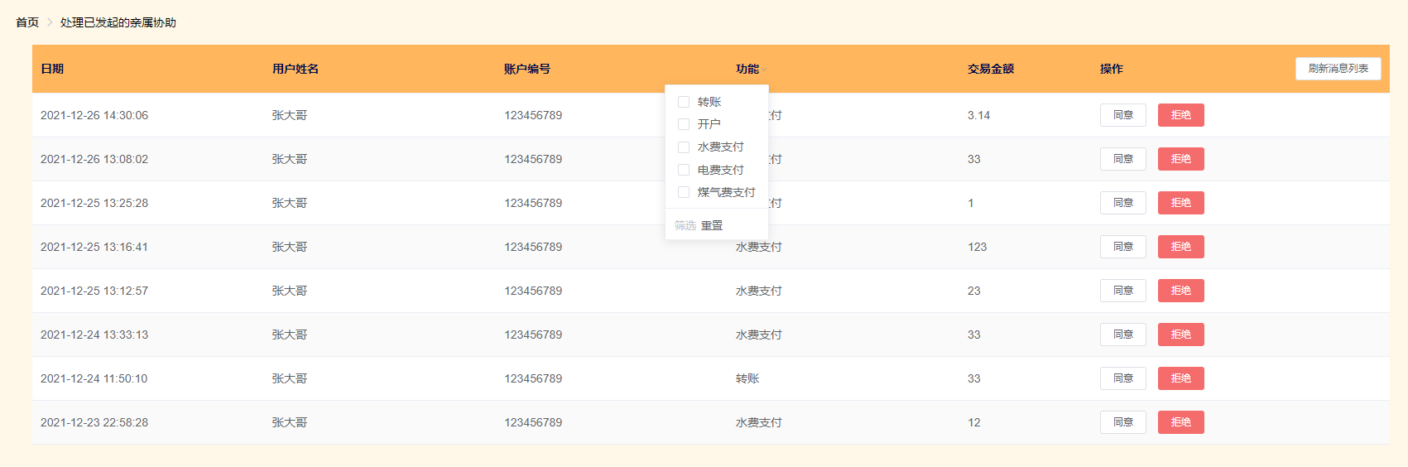

1. **View All Assistance Requests Generated by Desginated Relatives**

A user can view all of his or her completed assistance requests on this page.

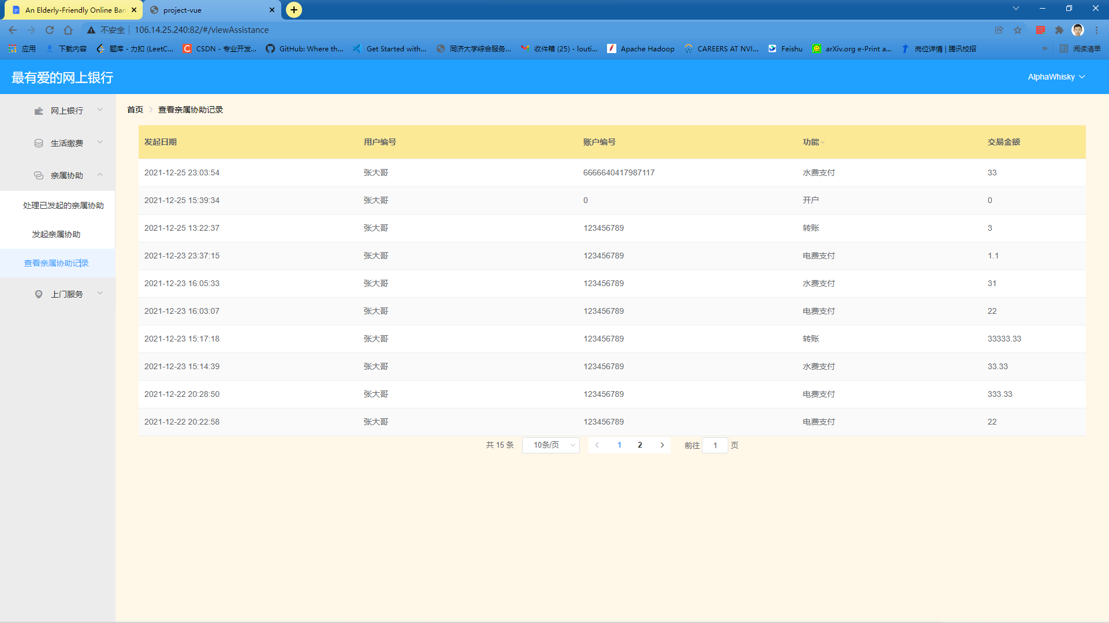

Also, for the convenience of our users, users can use the filter for this form to quickly locate the assistance requests they are looking for.

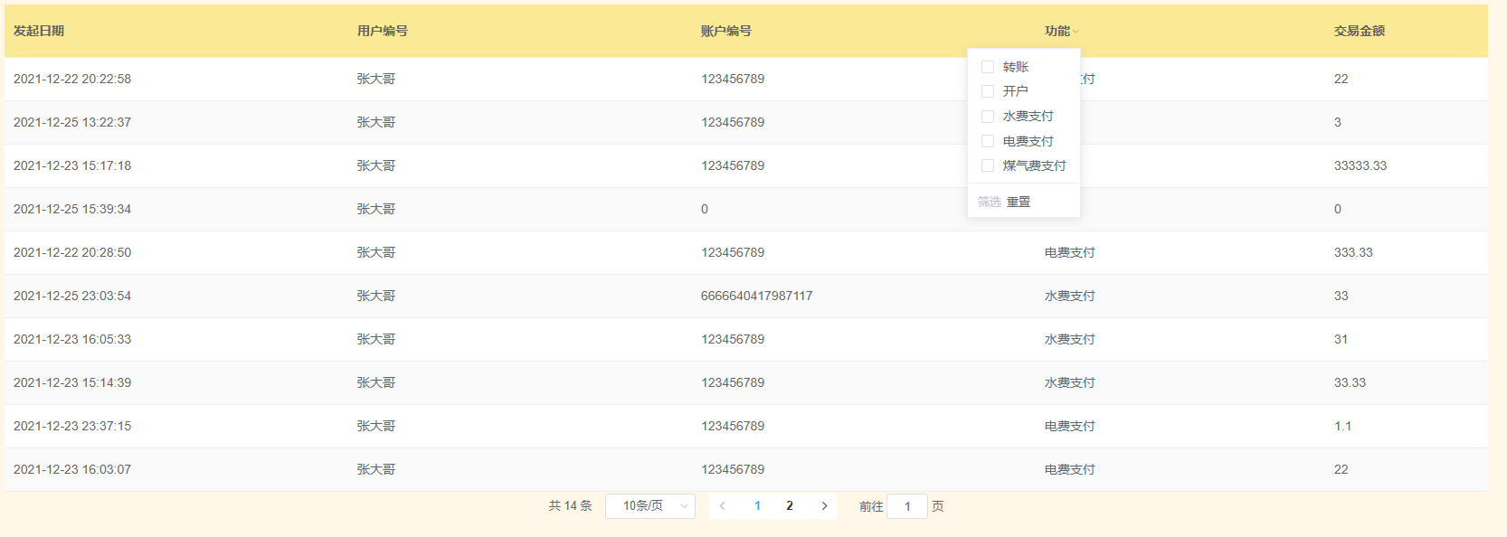

1. **Concierge Service**
2. **View All Concierges**

When you query the concierge list, you can make your choice considering time, gender and language preference. When you set the rule, the system will filter out concierges that you need.Ans then you will know ample information about concierges who are at service.

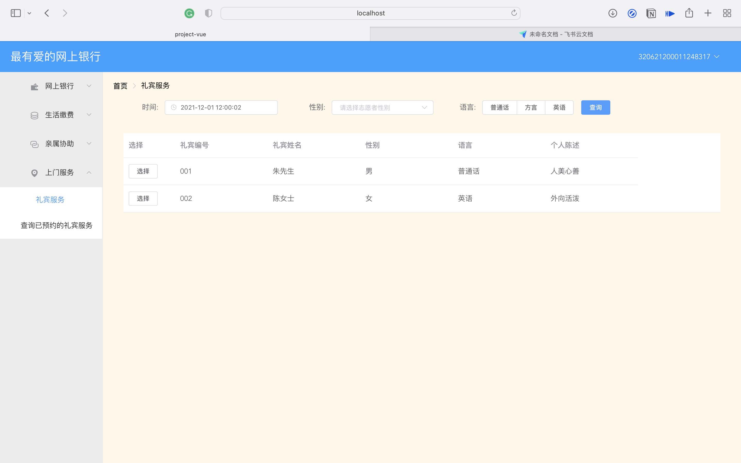

1. **Make an Appointment with a Concierge**

After viewing all concierges according to your preference, you can make a decision to choose one concierge to help you at specific time. Before you make the choice, the system will check if you already have one appointment that has not been realized and will send an alert that you can only make one appointment at a time.

1. **View the appointment**

After making an appointment, this page will show your appointment information.

